ILRS Technical Workshop

Kötzting, Germany

October 28 - 31, 2003

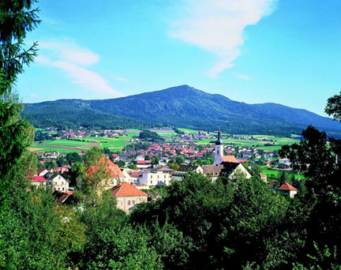

Agenda

Theme: Working toward the full potential of the SLR capability

Areas of Attention:

- What are our current limitations and how do we overcome them?
- How do we reach 1mm accuracy for each laser ranging component (ranging machine, refraction, spacecraft center-of-mass, data processing, etc)?
- How do we monitor our improvements?

Tuesday, October 28

9:00 Opening

Welcome – U. Schreiber (TUM/ILRS) (5 minutes)
D Grünreich or J. Ihde (BKG) (5 minutes)
H. Drewes (CSTG) (5 minutes)

Introduction – Werner Gurtner/Mike Pearlman (ILRS) (15 minutes)
Topics and goals of the workshop, schedule, etc.

Invited – Markus Rothacher
The special role of SLR in view of inter-technique combinations

10:00 – 10:30 Break

Operations (How do we make our current systems work better?)

1. A review of station performance and data throughput (20 minutes)
(CB - Mike Pearlman, Van Husson)
Is our network performance and data throughput improving? What should we expect? Where are the big deficiencies? Where would improvements have the biggest impact?

2. Daylight ranging (1.5 hours)
(NE WG - Werner Gurtner, Ulrich Schreiber)
Why is daylight ranging so important? Why is the daylight ranging so poor? What is the experience at the most successful stations? How do we improve it? What are the hardware issues? What are the software issues? Would better predictions help? What are the current limitations? Each station should come prepared to participate.

12:30 – 14:00 Lunch

3. Implementation of the new Engineering Data File (1 hour)
(NE WG - Georg Kirchner, Van Husson)
What is the definition of the Engineering Data File and its components, desired results and expectation, status of development, plan for development and implementation? How do we get all of the information and how do we make it user friendly?

4. Local survey monumentation and eccentricity measurement (0.5 hour)
(Wolfgang Schlueter)

Summary of the IERS Meeting on the IERS Workshop on Site Collocation

How do we get the long-term, stable observation monument and local survey control monument network for all laser ranging systems, fixed and transportable so we can connect our measurement over space and time to 1 mm? What are the recommended local survey, computation, and archiving methods necessary to achieve the desired accuracy (1 mm) for the eccentricity values. How do we design the local networks? How do we know that we are achieving 1 mm? Is it possible to do this using local permanent control methods rather than launching episodic survey campaigns? How long has it been since local surveys were conducted at stations?

15:30 – 16:00 Break

5. Improved data QC at the stations (1 hour)
(NE WG - Georg Kirchner, Van Husson)
What data errors are presently seen at the Data Centers? What data screening do stations currently perform? What minimum standards should we establish to test data integrity and "reasonableness" of content? Should we have standardized routines? Should they be mandatory? Should we delete data that does not satisfy a minimum requirement? Each station should come prepared to participate.

6. How shall we handle dynamic priorities? (1 hour)
(Mike Pearlman)
How do we make localized priorities and tradeoffs? Should different applications be prioritized differently? How do we protect sensitive satellites such as ICESat and ADEOS-II? How do we address difficult missions like LRE? A strawman will be presented for discussion purposes.

18:00 End of Session

Wednesday, October 29

9:00 Begin Session

7. System Calibration (2 hours)
(NE WG - Ulrich Schreiber, Ivan Prochazka)
Have we made any improvements since the Florence Workshop? Are stations monitoring their calibrations and testing for reasonableness? What is our experience to date on timing unit calibration? What can we do to maintain the calibration consistency over periods without tracking? Should we be doing more frequent barometer calibrations? Stations should come prepared to participate.

11:00 – 11:30 Break

8. Refraction modeling (1 hour)
(DFP WG - Stefan Riepl, Erricos Pavlis)
How good are our zenith delay models and our mapping functions? How much improvement are we seeing from newer models and how much can we expect? How large are the influences of horizontal refractivity gradients and nonlinear effects? What are we getting from the low-altitude tracking? Which missions need improved refraction corrections?

9. Developing and implementing the new consolidated prediction format (0.5 hour)
Cancelled

12:30 – 14:00 Lunch

Modeling (How do we make better corrections to our data?)

10. LEO Data Submission - how fast is fast enough? (0.5 hour)
(DFP WG - Graham Appleby, Rolf Koenig)
What do we really need? What kind of turnaround is reasonable? Practicable? How fast can all of the components of the system respond? What are we going to do with it? Do all LEO satellites need this?

11. Spacecraft center-of-mass modeling (1 hour)
(SP WG - Graham Appleby, Toshi Otsubo)
How does the satellite center of mass depend on station configuration and operating conditions? How do we develop systematic and realistic ways of quantifying return energy level and other pertinent parameters? Where do we stand in cataloguing the spacecraft cross-sections and center-of-mass corrections? How do we bring in supporting information like spacecraft attitude? How good are the dispersion models for dual wavelength applications? How do we make this user friendly for the analysts?

15:30 – 16:00 Break

12. Two-Wavelength Tracking (1.5 hour)
(NE WG - John Degnan, Cinzia Luceri)
What is the experience to date with dual two-color ranging? What are systems getting now? What advance in refraction correction can we expect from the current two-wavelength systems? Emphasize the critical role that the current systems are playing in the development and evolution of the two-wavelength systems, What parameters will we need to reach the 1-2 mm refraction correction, etc. What satellites are most important for two-color work? Should we accommodate both separate range measurements and differential measurements? Is the calibration procedure well defined? What changes do we need in data flow, formatting, and archiving? What changes are needed in data reporting? What do the analysts need to use the data and make it useful? Do we need wavelength dependent center-of-mass corrections? Is there a polarization issue?

17:30 End of Session

Evening

20:00 – 22:00 Governing Board Meeting

Thursday, October 30

9:00 Begin Session

Analysis (How do we generate the best data products?)

13. Pilot Projects (1.5 hours)
(A WG – Graham Appleby, Mark Torrence)
Where do we stand on the Pilot Projects? How well do the different groups agree? How well are we doing with analytic studies of system bias? Are we getting consistent results from different analysis centers? What is the prognosis for consolidated products? What are our current data and modeling limitations? What are the dominant issues?

10:30 – 11:00 Break

14. New approaches (0.5 hours)
(A WG – Erricos Pavlis, Mark Torrence)
Are there new approaches for analyzing data? Multi-satellites? Multi-technique? How far can we reduce our observation interval (days?)? Why is there and offset between SLR and GPS? How is SLR used for altimetry? Are there better ways to use the data? What new data products should we provide (Geocenter time series, time varying gravity field, orbits, etc.)?

15. KHz ranging and its impact (1 hour)
(NE WG - Georg Kirchner, John Degnan)
Where do we stand with kHz ranging? What are the advantages and problems? How soon can we expect a useful flow of data? Who is building these systems? What is the impact on the ILRS data system? Can we rethink the definition of normal points?

12:30 – 14:00 Lunch

New Technologies (Where are we going?)

16. SLR 2000 (1 hour)
(NE WG - John Degnan)
Where do we stand? What major issues still need to be resolved? When do we expect the prototype to be operational? What is the plan for replication, testing and deployment?

17. Automation (1 hour)
(NE WG - Ben Greene, Werner Gurtner)
What does automation mean? What is our experience to date? What can we reasonably expect? How does this interface with remote control?

16:00 End of Session

20:00 - 23:00 Banquet

Friday, October 31

9:00 – 9:20 Keynote from IVS
(W. Schlueter)

9:30 – 12:00 Plenary Session
(Mike Pearlman, Werner Gurtner)
Summary of each session by the session chairs.
Evaluation of the workshop. Correct format?
Discussion of Operational and Administrative Topics

12:00 End Of Workshop
ILRS Workshop

Kötzting, Germany

October 28 - 31, 2003

Workshop Summary

Approximately every two years the ILRS holds its traditional International Laser Ranging Workshop to examine progress in the relevant technologies and system developments that are pacing the evolution of SLR. This tradition has built up over the last thirty years with the Thirteenth Workshop being held in Washington in October 2002 and the Fourteenth planned for San Fernando, Spain in June 2004. This venue gives the analyst, the practitioner and the station representatives the opportunity to see what's new and who is doing it.

Periodically special workshops are held to focus more on seeking solutions to engineering and operational problems or to improving operations and performance in an organized manner across the network. Sometimes these meetings are held in conjunction with the traditional workshops; other times they are organized separately to concentrate our energies on the issues at hand.

In October 1995 a meeting on New Technology was held in Wettzell. In September 1999, a meeting on calibration issues was held in Florence. In March 2002, a meeting on the detection and elimination of errors was held in Herstmonceux.

The Koetzting Workshop was organized to examine how we could work more effectively toward achieving the full potential of the SLR capability. We wanted to ask such questions as: What are our current limitations and how do we overcome them? How do we reach 1 mm accuracy for each laser ranging component (ranging machine, refraction, spacecraft center-of-mass, data processing, etc)? How do we monitor our improvements?

We were fortunate to have Prof. Markus Rothacher as an invited speaker from the IERS to start the meeting off with a presentation on the special role of SLR within the context of inter-technique combinations

Topics discussed in the sessions included improved data throughput, daylight ranging, comprehensive on-line engineering files, inter-technique ground survey techniques, improved quality control at both the data centers and at the stations, the implementation of dynamic priorities, improved system calibration, better refraction models, rapid data throughput on LEO satellites, improved spacecraft center-of-mass corrections and documentation, two wavelength ranging, and the emerging role of automation to SLR.

We also had the opportunity to review the Analysis Working Group progress in its Pilot Projects and their advancement toward unified ILRS data products, new approaches in analysis techniques, and kilohertz ranging including the SLR2000. We also had a presentation from one of our sister services, the IVS, on its present activities and future plans.

In this document, each of the session organizers has provided a summary outlining the key issues and either solutions with recommendations and actions items or a plan of how to arrive at that point.

The plans, recommendations and action items elucidated will be used by the ILRS for guidance on how to set our priorities and how to proceed.

We wish to thank Ulrich Schreiber, Thomas Klügel, the BKG, and the Wettzell Station for their hospitality in hosting this meeting in Koetzting.

The Special Role of SLR for Inter-Technique Combinations (Markus Rothacher)

Introduction

The IERS is working towards construction of a rigorous combination of results from space observation techniques. This combination will make use of the strengths of the individual observation techniques and profit from co-location of instruments at both sites and satellites. The effort is to ensure consistency between all techniques by identifying the difference between technique-specific systematic biases and genuine geodetic/geophysical signals. The final goal is to assure that all common parameters of all observing techniques are rigorously combined as consistent input to the IGGOS project (Table 1).

Table 1. Parameter Space for Combinations; “X” indicates contributes to the parameter estimations, “(X)” indicates some contribution.

Parameter Type | VLBI | GPS/GLON. | DORIS/PRARE | SLR | LLR | Altimetry
Quasar Coord. (ICRF) | X
Nutation | X | (X) |  | (X) | X
Polar Motion | X | X | X | X | X
UT1 | X
Length of Day (LOD) |  | X | X | X | X
Sub-Daily ERPs | X | X
ERP Ocean Tide Amplitudes | X | X |  | X |  | X
Coord.+Veloc.(ITRF) | X | X | X | X | X | (X)
Geocenter |  | X | X | X |  | X
Gravity Field |  | X | X | X | (X) | X
Orbits |  | X | X | X | X | X
LEO Orbits |  | X | X | X |  | X
Ionosphere | X | X | X |  |  | X
Troposphere | X | X | X |  |  | X
Time/Freq. Transfer | (X) | X | (X)

Station Height

SLR is in a unique situation concerning atmospheric refraction. The troposphere is dispersive for SLR, but not for microwaves. For SLR, the dry delay can be modeled with pressure data at the site, and the wet delay is quite small. All other techniques (GPS, VLBI, DORIS, altimetry, InSAR, etc.) suffer from the same tropospheric refraction effects, and similar ionospheric refraction effects. These other techniques have tropospheric refraction as the or a major error source. Only SLR can help to detect biases due to atmosphere mis-modeling common to all other techniques. The wet delay for GPS/VLBI/DORIS can be up to 40 cm whereas for SLR it is only up to 6 mm. The troposphere zenith delay parameters have to be estimated for microwave techniques, but not for SLR.

SLR is the only technique where, in general, no clock corrections have to be estimated. GPS phase analysis requires the estimation of receiver and satellite clock parameters for every measurement epoch. VLBI analysts typically parameterize receiver clock corrections about every hour (between stations). DORIS analysis requires a clock bias to be estimated. The estimation of clock parameters degrades the recovery of station height. However the estimation of a range bias for an SLR station corresponds to a receiver clock correction as estimated in GPS/VLBI/DORIS analyses and “destroys” the much more favorable height estimation of SLR.

In summary, microwave techniques have inherently less accurate height estimation because of the extreme correlations between the estimation of height, clock, and troposphere zenith delay. Height estimation should be no problem for SLR; the heights should be “perfect.” The SLR technique is very important for absolute height estimation, but the estimation of range biases should be avoided to the extent possible in SLR analysis.

Absolute Scale

GPS receiver and satellite antenna characteristics are generally not accurately known, changing with elevation and azimuth. This variation can cause GPS results to be elevation cut-off dependent. There may be large systematic effects due to receiver and satellite antenna phase center corrections. Additionally, any change of GPS receiver or antenna equipment causes jumps in height estimation. GPS is too affected by these systematic effects to allow accurate absolute height and absolute scale determination in the global network and for ITRF. VLBI telescopes are huge heavy structures resulting in telescope deformation. The deformation may bias VLBI results through some elevation dependence. SLR does not have the antenna problems of either GPS or VLBI; any deformation should be small, and there are no phase center variations. So SLR is well suited to define scale of ITRF, but the calibration of the SLR system has to be very accurate and reliable.

Geometry and Gravity

SLR is one of the major techniques establishing a link between the three pillars of geodesy: geometry, Earth rotation, and gravity. SLR is a critical technology for the determination of the geocenter: the relation between origin of ITRF and low order harmonics coefficient C_{(1,0)}, C_{(1,1)}, and S_{(1,1)} of the Earth’s gravity field, and the principle axes of the Earth’s inertia tensor: the relation between Earth rotation, orientation of the gravity field (C_{(2,1)}, S_{(2,1)}), and ITRF orientation. The SLR data enables the determination of gravity field variations that are due to exactly the same Earth processes (e.g. from geophysical fluids) as variations in Earth rotation and deformation (geometry). SLR is a link between the three pillars of geodesy, and is very important for the IGGOS integration concept and for IERS reference frame definitions.

Validation of satellite orbits

SLR measurements are successfully used to validate GNSS (GPS, GLONASS, in future, Galileo, etc.) orbits However, there still is a systematic bias of about 4-5 cm between GPS orbits determined from microwave and SLR observations; the source of this offset is still unclear. SLR may also become important for Galileo satellite orbit validation. Much progress has been made in precise orbit determination of LEOs thanks to validation with SLR allowing the detection of systematic orbit errors. SLR allows the evaluation of different estimation strategies (kinematic, reduced-dynamic, etc.) and software packages. SLR observations are extremely valuable for POD studies, and POD becomes ever more crucial for new satellite missions.

Conclusions:
- There are few SLR observations, but there are also few parameters to estimate.
- SLR is the only optical technique (unique to assess atmospheric biases).
- No troposphere estimation necessary for SLR (correlations, biases).
- No clock correction estimation is necessary for SLR (correlations, biases) which allows good height estimation.
- SLR can reliably estimate absolute scale and heights because it does not have theantenna problems of other techniques.
- SLR provides an important link between gravity, Earth rotation, and geometry.
- SLR is crucial for progress in POD.

SLR is a unique partner in the goal of a rigorous combination of the space geodetic techniques (IERS and IGGOS). The individual techniques should feel as a part of a larger whole with a common goal rather than working in competition. Interlinked, the techniques are much stronger and it is more difficult to isolate and cut individual techniques.

Session 1. A review of station performance and data throughput (Mike Pearlman)

The network data yield continues to increase as more satellites are added to the tracking roster and stations implement more automation. The bulk of the data however are still generated by a small number of stations. In the last quarter, five stations provided more than half the data; sixteen stations provided 75% of the data (see below). One third of the stations are not providing data at sufficient volume to be of routine use to the analysts. Most of the stations are delivering their data within 4 hours (see below). A few are in the neighborhood of 12 to 18 hours, in part due to operational constraints. Transmissions problems also play an occasional role.

All but a few of the stations provide data of sufficient quality at the moment, but there are still range bias issues. We must implement engineering tests at the field stations to recognize and address problems early and at the point of local expertise.

In response to the great diversity in data production and the relative utility to the user, the ILRS has implemented a regime of station qualification. As of January 1, 2004, those stations performing above minimum qualification criteria will be categorized as Operational Stations. Those that do not meet the criteria will be categorized as Associate Stations. At the moment, 16 stations are performing below the operational level. It is anticipated that the minimum qualification criteria for Operational Stations will increase over time to keep pace with increased demands on the network and the ILRS.

In mid-2004, the ILRS will add a requirement for a collocated IGS receiver at each Operational SLR Station. Most of the SLR stations presently performing at the operational level already satisfy this requirement.

It is recognized that mobile stations may occupy sites for short periods of time for specific applications (e.g., FTLRS in Chania for altimetry support and TROS in Urumqi for the Chinese National Survey program). These systems should probably be characterized some other way, since they do not lend themselves to the long-term reference frame requirements of SLR.

A more detailed look at the distribution of satellite support shows that we need to do a better job tracking both the very high and the very low satellites.

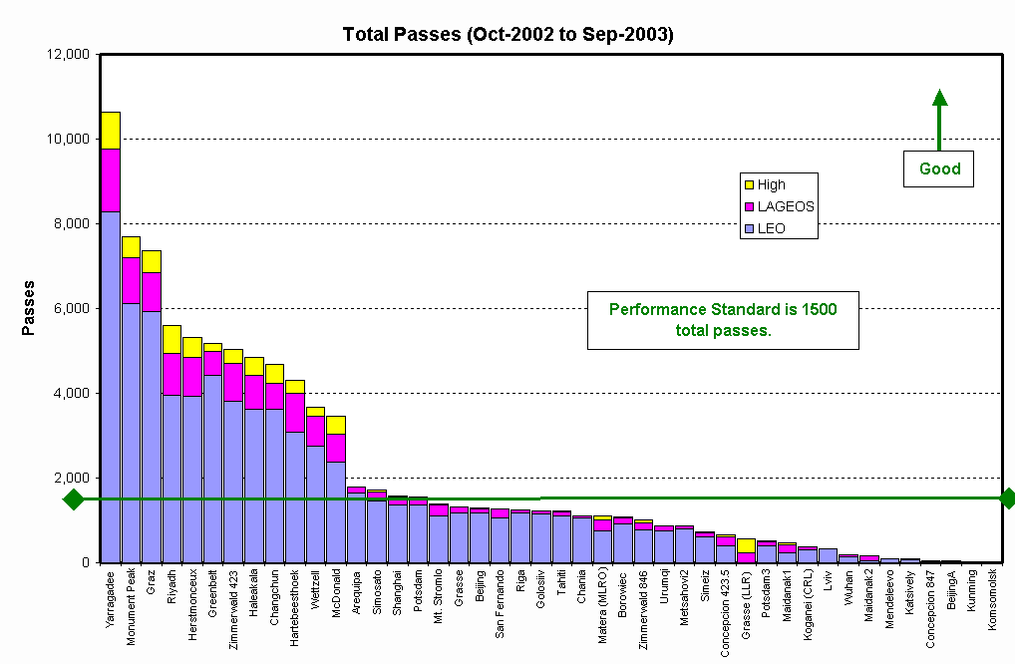
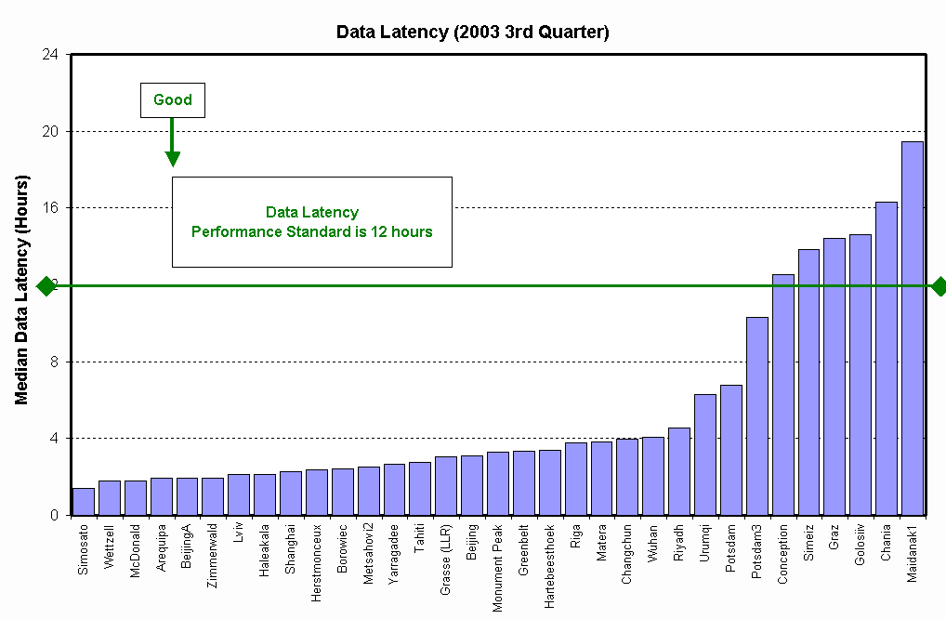

Session 2. Daylight ranging (Werner Gurtner, Ulrich Schreiber)

As one can see from the statistics below there is a considerable imbalance between passes taken in daylight and passes taken at nighttime. The figure below gives an overview of the network status.

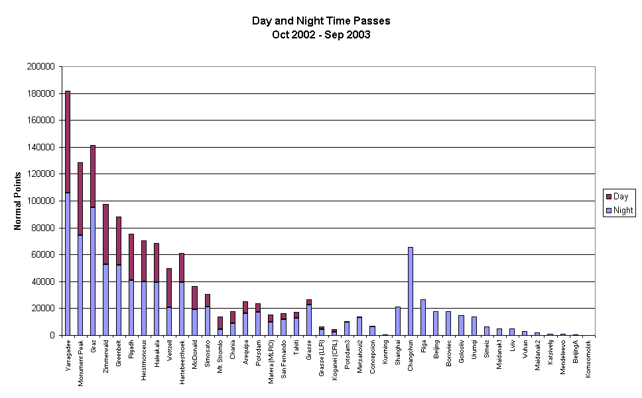
Turbulence as a very local condition might be contributing with as much as 10 arcseconds of error in pointing, increasing the difficulty in acquiring data. However this will apply only to systems with a very collimated beam. Degradation of the telescope orientation by direct sunlight exposure may require a mount-model based on star observations during the day. Mount shielding helps to avoid deformation of the telescope in the first place.

Action Item: The BC will work with stations that can do daylight mount modeling such as Herstmonceux, Grasse, SLR2000 and Wettzell to make information available about how this capability can be achieved.

Predictions are also an important issue for daylight ranging, particularly for those stations with narrowly collimated beams. Systems with a larger beam divergence and relatively large field of view have less trouble ranging in daylight hours as long as the have adequate signal to noise ratio.

The HTSI predictions (which are issued daily but cover a 5 day span) show a 10 - 15 msec timing offset at midnight UT. This is a consequence of the IRV tuning process. HTSI has written a software repair, but it has yet to be implemented.

Action Item: HTSI should implement the repair to its IRV tuning process to correct the midnight offset problem.

An offset of up to 15 msec is observed in GFZ predictions for GRACE and CHAMP. The AIUB server currently provides both drag functions and time offsets for the predictions.

Action Item: The CB will ask GFZ if they can speed up the prediction cycle for CHAMP and GRACE to improve data acquisition.

There is also a midnight-offset problem with the ESOC predictions on Envisat. The problem stems from a lack of IRV tuning. NERC SGF has alerted them about the problem.

Action Item: The CB will remind ESOC of the offset issue and see if we can offer them any help.

It was also suggested that we use the CODE predictions for GLONASS and GPS, which are generated from precise orbits based on the IGS tracking network.

SLR systems with kHz repetition rates have demonstrated a much reduced acquisition time.

Recommendations:
- Stations: Some stations are using a narrow spectral filter and a frame grabber in order to adjust the pointing of the transmit system. Graz uses a filter of 0.3 nm around the wavelength of the laser, while Herstmonceux uses a 0.15 nm filter.
- Prediction Centers: Shorten IRV prediction generation cycles for the difficult satellites to the shortest meaningful value!
- Stations, Data Centers: Keep the delay of LEO data submission as short as possible!
- Strict request from the Analysis group: Day and nighttime observations give a much better data distribution of observations and therefore enhance the quality of the SLR measurements. Stations, please observe day and night!

Session 3. Implementation of the new Engineering Data File (Georg Kirchner, Kalvis Salminsh)

The Engineering Data File (EDF) concept mainly consists of storing all available information for each calibration record, and, in the future, for all ranging records; the stored information should contain all the relevant hardware descriptions, and all of the results collected during calibration including statistical values, meteorological values, and any additional information that is desired by the station.

There are several advantages of storing all this information:
- A continuous, consistent technical history of the station is created automatically, allowing checks of continuity, jumps, drifts etc. of any stored parameter at the station, whether it is recorded manually or automatically.
- The same files will be a valuable tool for analysts to correlate, results from orbital analysis with the technical history of any station.
- Stations can now easily compare their specific setups and their respective results, allowing better insights into deficiencies, capabilities, possible improvements, etc.
- All that can be done with simple software or scripts, which furthermore, once written and tested, can be used by other stations.

Kalvis Salminsh from Riga investigated various possibilities to implement this EDF concept. Based on his research, he recommended that the EDF be implemented in the Extensible Markup Language (XML) format. XML is a standard way of describing data (i.e., independent of any programming language or application). XML is a text-based language for creating structured documents, and an open standard managed by the World Wide Web Consortium (W3C). XML is also supported with a great deal of freeware or inexpensive tools. Furthermore, new tags to define specific data can be easily added, with full backward compatibility.

A so-called schema contains the names of the parameters which are to be stored in the XML file; an initial version of this schema has been developed already and will be distributed, together with installation guide lines, examples, tools, etc., to those SLR stations which have already agreed in Koetzting to participate in this test phase (Herstmonceux, Concepción, Zimmerwald, Wettzell, Potsdam, and Graz) within the next few weeks. This schema will be maintained or augmented by Kalvis according to any requirements from the participating stations.

In a first test, using this preliminary schema, calibration data from Herstmonceux and Graz for July 2003 were converted by simple scripts into XML files. As a result, a simple comparison between these two data sets showed a plot of a small, remaining calibration constant drift over temperature, with the same scale and direction for both stations, pointing to a similar slight temperature dependence of the SPAD power supply used in both stations.

Such an XML based data exchange/data storage system could also be used for other SLR issues, e.g., the ILRS Normal Point (NP) format. We should also consider developing an XML schema for NP files, which could then be used in parallel with the present NP format. The advantage of such an approach is that in the XML NP file, any desired additional information can be packed, for use by the analysts, without having to go through a long, cumbersome, and by no means backward-compatible, change in the NP data format. Similar advantages could be provided with XMP for a new prediction format system, or for the site logs.

Session 4. Local survey monumentation and eccentricity measurement (Wolfgang Schlueter)

A workshop devoted to “site co-location survey objectives, methods, and issues“ was organized by the International Earth Rotation and Reference Systems Service (IERS). The workshop took place in Matera, Italy on October 23-24, 2003.

Presently, the quality of the station coordinates resulting from the various space techniques is in the order of a few millimeters in the horizontal and about 1 cm in the vertical component. Precise local ties are the perfect link to enable a rigorously combination of all space observing techniques by their common parameters in order
- to study the systematics going along with each space technique and,
- to establish a unique, high-precision terrestrial reference frame.

In previous analyses, one of the major limiting factors was the characteristic and the availability of accurate local tie information for all co-located sites around the globe. In 5 sessions at the workshop, attention was given to:
- Co-location sites and their importance for the ITRF
- Site surveys
- Analysis and SINEX
- Reporting and Archiving
- Planning for 2004

More than 30 participants from Australia, South Africa, USA, and Europe discussed various examples, analysis methods, and survey strategies. Finally, guidelines for co-location site surveys and report templates were proposed. The potential availability of survey teams as well as the planning for surveys in 2004 were investigated.

The important recommendations are the following:
- Local ties between co-located instruments should be determined with an accuracy of 1 mm, with full variance/covariance information, available in SINEX format.
- Local survey measurements should have the same importance as and should be treated like any of the space geodetic techniques. Site coordinates (VLBI, GPS, SLR, DORIS) should be better tied to the ground. The quality of local ties should be such that they can be assumed true for the combination.
- All GPS sites close to other geodetic techniques should be part of the IGS routine processing.
- A database will be established at IERS (Central Bureau and ITRS Product Centre) for all information in connection with site co-location (list of co-location sites, local ties in SINEX, co-located instruments, site maps and pictures, survey reports, survey status, site events and history, etc.).

To support the local tie activities an IERS Working Group on Local Survey will be recommended for adoption by the IERS Directing Board. The charter of the working group will be the coordination and assistance in local tie analysis as well as SINEX file generation.

The workshop information (program, presentations, and recommendations) is available at the IERS webpages (http://www.iers.org/workshop_2003_matera/programme.html). The proceedings will be published as IERS Technical Note No. 33.

Session 5. Improved data QC at the stations (Georg Kirchner, Mike Pearlman)

SLR has a long history of improvements in measurement capability and ranging accuracy. It also has a long history (or “tradition”) of providing data that are sometimes biased, corrupted, or incomplete. Some of these problems are detected at the data centers during routine checks of incoming data, others are visible only after orbital fits, etc.

Not all of these problems can be detected by checks at the stations; however, the most trivial errors, such as meteorological data out of range, jumps or drifts in calibrations, noise instead of real data, etc. can be easily seen by simple checks and by following some procedures at the stations before sending the data. The general idea is to strive for delivery of checked, valid data. In view of the amount of SLR data produced today, it was also suggested that we reject any suspicious, or obviously erroneous data to improve overall SLR data quality, and to push SLR stations to check their data and their procedures.

A survey of stations performed some months ago showed that only a few stations are checking normal point (NP) data before sending them to the data centers; most stations do not apply ANY checks.

To facilitate implementation of such basic checks at all stations, Herstmonceux agreed to upgrade its internal NP check program for easy implementation and general use at any SLR station. A first version of that program, including source code, implementation guide, examples for station template, etc., will be made available shortly.

At the EUROLAS workshop in Herstmonceux in spring 2002, a recommendation was made to require a minimum number of SLR data points per NP to improve NP data quality by avoiding poorly defined NPs. The criteria suggested was a minimum of six data points per NP in daylight and three data points per NP at night. These criteria were relaxed for stations with low data rates. The ILRS Governing Board subsequently agreed with this policy.

However, in a lengthy discussion in Koetzting, there were some counter arguments were made:
- From analysts: in spite of the available amount of SLR data, they would like to have EVERY measured point.
- In the case of multi-photon receivers, even single point NPs are well defined.
- In the case of very small (FTLRS) or low-repetition-rate (Metsahovi) SLR stations, it was always agreed that this process could be relaxed.
- Each NP data point includes the number of full-rate data points that were included in its formation, thereby providing the analysts with a mechanism for screening.

At the Workshop in Koetzting, we agreed that the criteria could be relaxed and that stations could exercise their own discretion in setting minimum criteria (even a single data point) if they felt that it improved their data quality. Such a criteria must be documented as a comment in their site logs.

The ILRS Governing Board has redefined the minimum data point requirement as:
- Stations may set a minimum data requirement too low return rates should select their minimum points per NP as required;
- In general, the recommendation of 2002 (minimum points per NP: six for day, three for night) is still valid;
- Stations with high return rates could select also higher criteria; e.g., Graz with the kHz laser system is currently using a minimum of 100 points per NP for ALL satellites and has announced to possibly increase that to 600 points per NP for LEOs because of much better definition of the NPs in this case.

Additionally, a minimum number of NPs per pass was also discussed; however, analysts again wanted to see all of the data especially if single NPs could be well defined ones and data were very sparse (e.g., pass length limited by clouds).

Session 6. How shall we handle dynamic priorities? (Mike Pearlman)

We have examined a number of schemes for dynamically adjusting SLR tracking priorities to try to compensate for a dearth or an overabundance of data from specific satellites. The basic framework was that it must be (1) easy to understand and implement and (2) interpretable by each station even though different stations might be have different levels of success with different satellites.

The ILRS has traditionally prioritized satellites by orbital parameters and application. Currently 21 satellites are given 21 different priorities, sometimes distinguished by only a very insignificant difference in orbital parameters.

The new scheme proposed and approved by the Governing Board place the satellites in four categories, with the satellites in each category having equal priority. In each category, stations should try to equalize the number of passes on each satellite over the course of a few days. If the station has had many passes on one satellite on Category 1 and few passes on another, a little greater stress should be place on the satellite with weaker tracking to try to increase its data yield.

Category 1 | Category 2 | Category 3 | Category 4
GRACE-A | GFO-1 | Starlette | Etalon-1
GRACE-B | Envisat | Stella | Etalon-2
CHAMP | ERS-2 | Beacon-C | GLONASS-89
 | Jason | Ajisai | GLONASS-87
 | TOPEX/Poseidon | LAGEOS-1 | GLONASS-84
 | Meteor–3M | LAGEOS-2 | GPS-35
 |  |  | GPS-36

The Central Bureau will provide a daily index (+1/-1) to raise/lower the priority within each category of satellites that need more/less attention. The indices will be based on a minimum number of passes that we anticipate every 2 -3 days.

Action Item: CB will post the priority table daily with the updated indices on the AIUB server, so it will be available when stations access their prediction updates.

Session 7. System calibration (Ulrich Schreiber, Ivan Prochazka)

- Gross errors must be detected and diagnosed at the stations:
- Meteorological data
- Calibration values

Unless something has been adjusted, no change in the calibration value should occur between passes within a few hours. The stations should use the history of past measurements to crosscheck for data integrity.

- Quite a few blunders have appeared over time in the submitted data. This raises the question: “If Van can find them, then why not the stations?”

Action Item: All stations should generate a procedure to monitor consistency of their (calibration) measurements. Van Husson will provide a set of tests to help identify problems and possibly standardize procedures but monitoring the time history of key parameters can be a very useful diagnostic tool.

- Target structure and geometrical telescope properties are not a big problem for stable calibration. If they were you would not receive a signal through the telescope to the detector.

Action Item: Verify the survey of your system and target at least every two years.

- Electronics introduce time dependent errors. Those enter the measurements as range biases. The smaller the time dependence, the higher is the probability of unbiased data.

- Asymmetry between calibrations and ranging conditions (e.g., signal level differences) must be understood and remedied.

- Signal return properties such as mean, peak-mean, skewness and kurtosis are key indicators of performance and may serve in the process of checking consistency.

Action Item: Use this extra information

- Redundancy: A powerful way of checking system performances is system redundancy. There are many ways of creating redundant systems and use them in comparison.
- Co-location (costly)
- Cluster operation
- Portable Calibration Standard (flexible, cheap)
- Inter-System redundancy (Engineering Data File)
The potential of the Portable Calibration Standard so far has not been fully utilized.

- Inter-system redundancy is based on comparing the engineering data files exchanged with the other stations (future music).

Action Item: Definition of essential parameters and setting up a team to explore these capabilities

General Calibration Recommendations from the workshops in Florence and Toulouse:
- Make the calibration procedure friendly (no manual system changes or re-adjustments).
- Calibrate the SLR system at frequent intervals. Each satellite pass should have the corresponding pre and post calibration with maximum time span of one hour.
- Keep a calibration history file of all relevant parameters for consistency verification.
- Collect a sufficient number of valid echoes.
- Plot the calibration histogram and compare with a Gaussian fit. Check for anomalies in the distribution.
- Use optically correct calibration target(s).
- Use efficient spatial filtering.
- Use multiple targets at different azimuths and ranges to check the calibration setup and survey.
- Ensure a perfect alignment of the SPAD optics.
- Apply the gate for the detector early enough (50 ns and 100 ns for APD’s.
- Keep an appropriate echo data rate < 15% for APD’s < 80% for C-SPAD.
- Interpret properly the echo data rate.

Session 8. Refraction modeling (Stefan Riepl, Erricos Pavlis)

The session on Refraction Modeling featured the following contributions:

- Introduction Stefan Riepl
- Using ECMWF-Data for Refraction Modeling Ruediger Haas/Stefan Riepl
- Ciddor/Mendes Zenith Delay and Analysis of Low Elevation
Tracking Data Erricos Pavlis
- Absorption Lines and Nonlinear Refractivity Effects Yuri Galkin
- Refraction Modeling Fritz Brunner
- Using GPS Determined Water Vapor to Estimate Tropospheric
Wet Path Delay Attie Combrink

According to presentations by Erricos Pavlis and Cinzia Luceri the recently derived and tested refraction models show improvements in comparison to the traditional Marini and Murray model. According to Virgilio Mendes, a new formulation of the SAASTOMOINEN zenith delay formula leads to a minimization of systematic errors on a global scale. Attie Combrink presented a technique for local estimation of the wet path delay using GPS tomography.

Yuri Galkin outlined the inclusion of nonlinear absorption line effects in the determination of signal velocity. Fritz Brunner focused on a rigorous derivation of a refraction model for inter-technique comparison and two-color laser ranging. Such a rigorous derivation may also serve as a base to formulate a horizontal refraction gradient model.

As a result of the nonlinear absorption line effects and the stringent accuracy requirements for two color laser ranging, the Governing Board was requested to initiate an investigation program focusing on the feasibility of modeling the laser pulse propagation velocity in the open atmosphere with a relative accuracy of 1 part in 10E9.

Recommendations: The Ciddor-Mendes refraction model should be approved as the standard refraction model for SLR. Low elevation tracking should be enhanced to improve refraction model testing.

Session 9. Developing and implementing the new consolidated prediction format (Cancelled)

Session 10. LEO data submission - how fast is fast enough? (Graham Appleby, Rolf Koenig)

The theme of this session was to explore the practicalities and scientific need for rapid turnaround of laser tracking data from the network into the data Centers. If there are scientific or operational requirements for very fast availability of data which are perhaps not being accomplished, then it is important to understand where the hold-ups might be and what steps can be taken to improve the situation. If, on the other hand, there are no compelling reasons for improving upon the current cycle speed, then that situation should also be recognized. It is likely, however, that some improvements for some satellite missions will be identified.

Requirements

Koenig presented a science case that would benefit from the rapid availability of CHAMP laser tracking data. A GFZ operational program takes observations from CHAMP of GPS satellites undergoing occultation by the Earth’s atmosphere, from which can be derived information on the state of the atmosphere that is of value in numerical weather prediction. The technique is shown schematically in the GFZ figure below.

The essence of the technique is a fast turnaround of the products of the analysis. Part of this process is precise orbit determination, which is accomplished by a combination of GPS and SLR tracking data. However, the situation at present is that only a few percent of the actual global ILRS laser tracking data reaches GFZ in time to be included in this particular, time-critical analysis. To improve upon the situation, SLR data will have to be uploaded to and available at the data centers within an hour of the observations being made.

The GRACE mission also includes an occultation experiment, which will be turned on in the upcoming months. Koenig also introduced the TerraSAR-X mission to start in 2006, where fast data availability will also be needed for near-real time processing of orbits and derivation of resultant SAR products of value in Earth surface monitoring as, for example, rapid deformation measurements after earthquakes.

Gibbs (NSGF) presented some results comparing the quality of predictions for LEO satellites as a function of availability of tracking data. The rapid availability of SLR data is very important in feeding the time bias solutions that are used in the Herstmonceux-Berne Time Bias Server. Even for the now-standard daily IRV predictions, regular update of the along-track error in the predictions (time bias) has a significant impact on their quality. It was made clear from comments during the session that, particularly for the low-signal systems that have to work with narrow range gates, the quality of the predictions can make the difference between ranging success and failure. This particularly of course applies to the very low, high-drag satellites CHAMP and GRACE, but to a large degree also to all the low-altitude altimeter satellites GFO-1, ERS-2 and Envisat.

It was also noted (Appleby) that discussions within the Analysis Working Group on providing a weekly coordinate and Earth orientation product may generate a need for fairly rapidly available data from the LAGEOS and Etalon geodetic satellites in order that the best products may be computed.
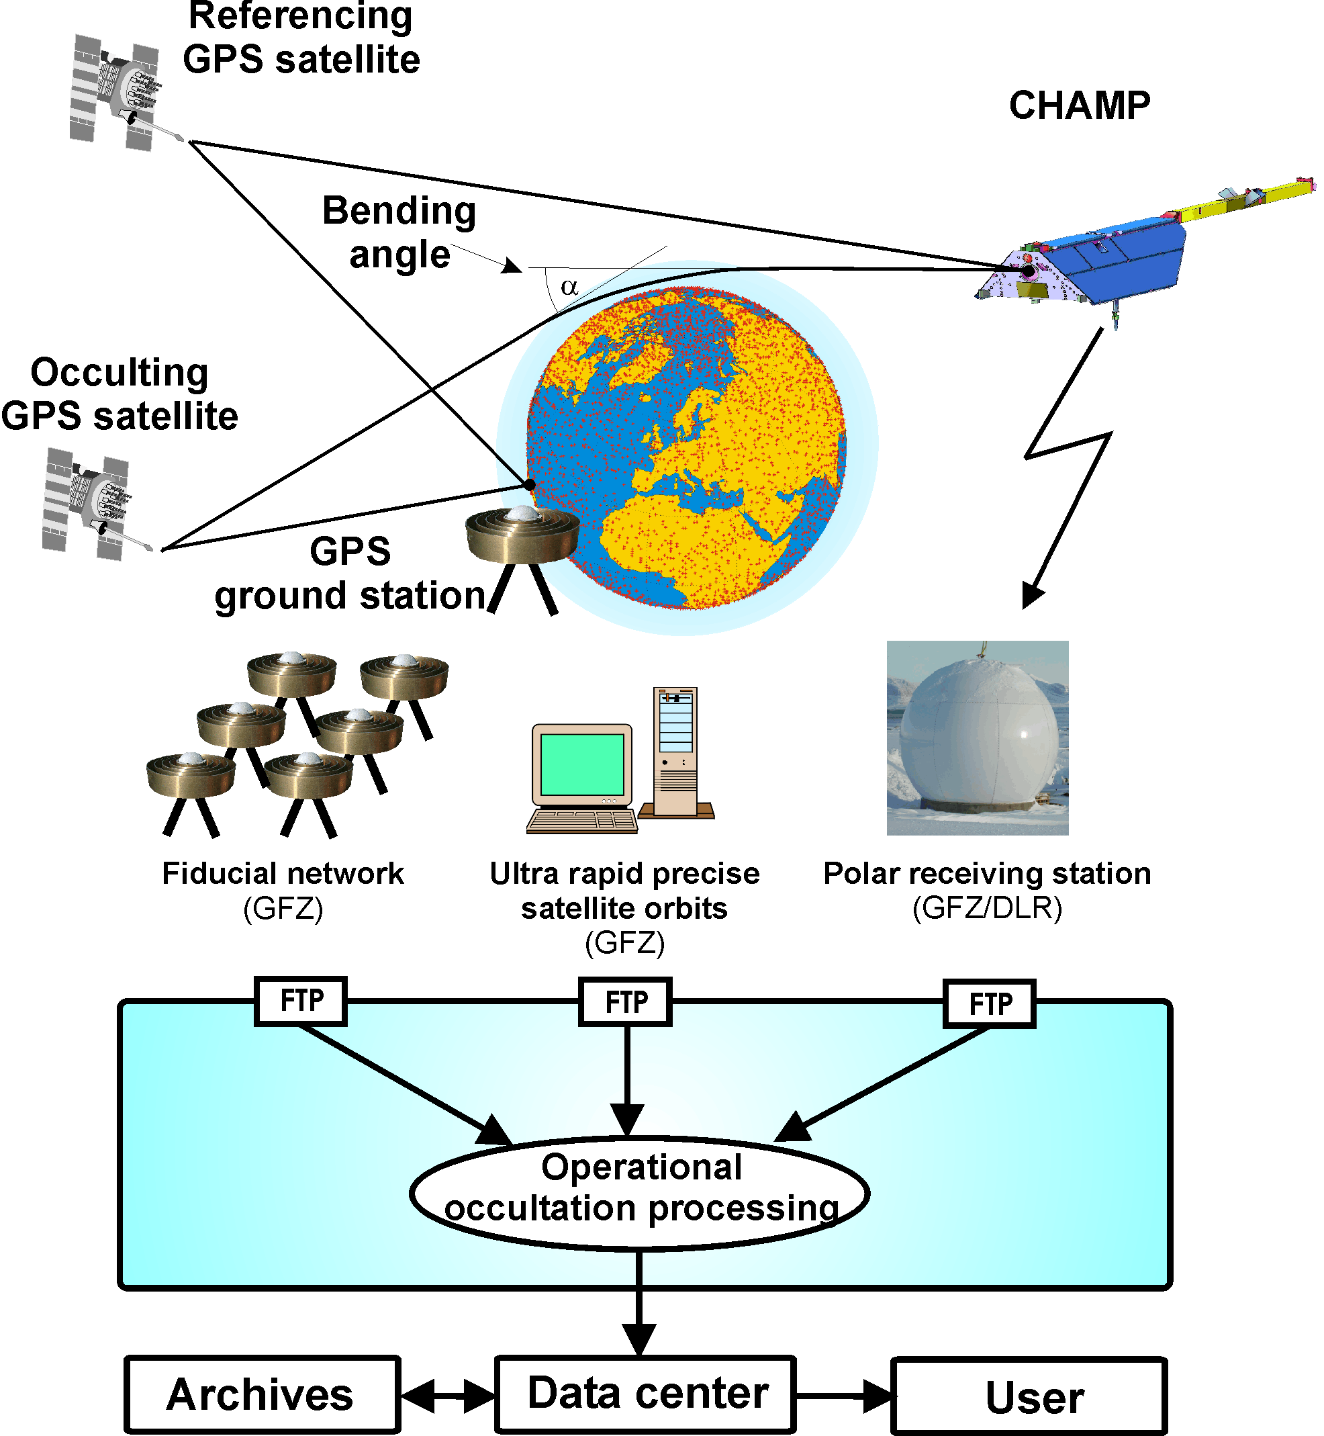

Overview of the operational infrastructure for measurements, data reception, transfer, analysis and distribution of CHAMP's radio occultation experiment (from Wickert, J., Beyerle, G., Schmidt, T., Marquardt, C., Koenig, R., Grunwaldt, L., Reigber, C.: "GPS radio occultation with CHAMP," in Reigber, C., Luehr, H., Schwintzer, P. (Eds.), First CHAMP Mission Results for Gravity, Magnetic and Atmospheric Studies, Springer, Berlin, Heidelberg, pp. 371-383, 2003)

Practicalities

Comments from those station personnel present at the session implied that a range of issues determines the rates at which the stations transmit the observations. For some groups it is normal to send the data to the operations centers immediately after each pass; others have pre- and post-pass calibration runs scheduled at specific times and as a result have variable transmission delays of up to a few hours. For at least one station the data processing is carried out during the daytime following each night’s observing session, implying a delay of several hours. Neither ILRS data center (CDDIS, EDC) has any problem in principle making the data available on a rapid turn-around, with EDC planning to implement a 15-minute turn around cycle.

Conclusions

There are scientific as well as ILRS-operational reasons for improving the speed of availability of normal point laser data. Specific cases involving CHAMP, the high geodetic satellites and the altimetry satellites were cited and discussed.

Recommendations:
- All ILRS elements should work towards making the data available to customers through the data centers as rapidly as possible, ideally within an hour of the observations being obtained.
- The CB should put out a request to the stations to give the highest priority to processing observations of CHAMP, GRACE, GFO-1, ERS-2, and Envisat.

Session 11. Spacecraft center-of-mass modeling (Graham Appleby, Toshi Otsubo)

Spherical Satellites

The main issue addressed by this session was how to pull together work that continues to be done on the dependence of satellite center of mass (CoM) corrections on station configurations and operating procedures. The spherical geodetic satellites are of most concern since they are both physically large and of fundamental importance in exploitation of the full potential of the SLR technique in defining the scale and origin of the terrestrial reference frame.

The CoM issue is shown schematically in the drawing above. A Gaussian pulse is transmitted from a ground station and reflected by all those cube corner reflectors that ‘see’ the pulse. Because of the curvature of the satellite, the reflected pulses will be both shifted in time relative to one another and vary in amplitude according to the apparent cross section and reflectance of the cubes as seen from the station. The result, if one considers the effect averaged over many such measurements, is a return pulse that is distorted and stretched with respect to the transmitted Gaussian pulse.

Theoretical work was presented (Otsubo and Appleby) to compute the return distributions from LAGEOS, Etalon, and Ajisai and to derive CoM corrections that depend upon tracking system parameters such as laser pulse length, detector (APD, MCP) and return signal strength (number of photons). It was re-iterated that the most accurate CoM value could be computed only for those systems working in the single photon regime. For multi-photon systems, not only are the numbers of returning photons most likely varying during passes, but also the effects on CoM corrections of internal delays within discriminating electronics are very difficult to ascertain. For the MCP systems it is likely that signal-strength variations result in less systematic range errors than for the CSPAD systems, but the CoM correction cannot be determined unambiguously.

Through orbital analyses for the Etalon satellites (Pavlis), it was demonstrated that CoM corrections are indeed system dependent, and an earlier CoM correction of 610 mm assumed appropriate for the MCP systems was found to be too large by as much as 20 mm for most of them. An investigation using full-rate data to estimate average return rates for the major systems for LAGEOS and Etalon (Wilkinson) suggests that there are significant differences among systems that may give some insight into the causes of mm-level bias determined for each system. The effect was graphically demonstrated in an analysis of LAGEOS-2 full-rate range residuals from the MLRO system at Matera (Bianco, Arnold, et al). The high return rate and very high precision of the data shows that the range measurements are modulated at the 5 mm level by satellite-attitude dependent variations in the mean reflection surface. The modulations were used to infer the spin rate of the satellite.

It was recommended that all station managers should attempt to quantify the effect on their range data of variable signal strength. Test ranging should be carried out to LAGEOS, Ajisai and (say) Envisat during which return levels are switched in a controlled way between minimum and maximum return levels within the systems’ dynamic ranges:

weak
strong
strong
weak

Results could be presented and discussed at the Laser Ranging Workshop in June 2004 in San Fernando, Spain.

It was concluded that for all systems apart from those working strictly in the single-photon regime, which will include the upcoming SLR2000 systems and for which accurate CoM values can be computed, analysts should continue to estimate a system-dependent CoM offset, constrained at say the 10 mm level. It is emphasized that this effect is not an instrumental range error or ‘bias’, but merely an uncertainty at the mm level in correcting very precise observations to the centers of mass of the satellites. More details of this research are given on the ILRS website at

http://ilrs.gsfc.nasa.gov/working_groups/signal_processing_wg/spwg_activities/

GNSS arrays

Orbital analyses imply that the smaller arrays on the newer GLONASS satellites cause less systematic elevation-dependent bias, at the expense of some reduction in link budget (Otsubo). In a related study using laser data and IGS-determined orbits it was concluded (Appleby and Otsubo) that an offset persists between the IGS-determined and SLR-measured heights of the two laser-tracked GPS satellites. Range data taken when the satellites are close to the local zenith give an accurate assessment of the radial offsets in the IGS orbits, which appear to be different for the two satellites; from a two-year analysis, for GPS-35 the offset is -6.2 ±0.7cm and for GPS-36 the value is -2.1 ±0.4cm.

Reflectivity Cross Sections

In a signal-level related study, a theoretical analysis has been carried out to compute cross-section values for the arrays of all existing and past ILRS-tracked missions (Arnold). The origins and quality of previously published values are unclear and this work places all cross section values on the same rigorous theoretical footing. The table of results will be placed on the ILRS website.

Session 12. Multi-wavelength tracking (John Degnan, Cinzia Luceri)

Hardware (John Degnan)

The need and accuracy requirements for multi-wavelength ranging are driven by the quality of the atmospheric models used to correct for the atmospheric delay in single wavelength systems. The ultimate performance of any model depends on inputs to the model, e.g., the accuracy of the in situ measurements of pressure, temperature, and relative humidity. For example, temperature and relative humidity measurement accuracies produce sub-mm range errors in the Marini-Murray (M-M) model but a 0.1 mbar pressure error (best case) can produce about 0.8 mm of range error at zenith and 2.4 mm of range error at 20º elevation. However, even if the model inputs had zero error, one must ask the question: How well does the model represent the physical atmosphere?

The effect of deviations of the vertical structure from hydrostatic equilibrium on M-M have been estimated to be less than 1 cm at elevations above 20º elevation [Hauser, 1989] as are the effects of horizontal gradients [Abshire and Gardner, 1985]. The M-M model is static (time-independent) whereas random fluctuations in delay due to turbulence effects are typically a few mm but can be a few cm at 10º elevation under conditions of strong turbulence (Abshire & Gardner, 1985). Although some competing atmospheric models are believed to be better than M-M at wavelengths below 500 nm due to better physics and at low elevation angles due to better mathematical approximations, they are all unable to take into account the aforementioned effects. With potential un-modeled errors at the cm level, the only way to unequivocally achieve mm-accuracy range measurements is through direct measurement of the atmospheric delay via multi-wavelength ranging.

Theoretical analysis has suggested that the optimum wavelength pairs for two-color ranging are the 2nd and 3rd harmonics of Nd:YAG at 532 and 355 nm respectively or the 1st and 2nd harmonics of the tunable Ti:Sapphire laser, nominally at 800 and 400 nm. This “Figure of Merit” analysis [Degnan, 1993] takes into account the wavelength dependence of the dispersion and transmission of the atmosphere, detector quantum efficiencies, nonlinear conversion efficiencies, and the beam divergence from fixed transmit and reflector apertures. In order to achieve 1 mm absolute accuracy in the atmospheric correction or even to validate existing models at the mm level, the Differential Time-Of-Flight (DTOF) between pulses at 532 and 355 nm must be measured with an absolute accuracy of less than 0.6 psec. Although alternative wavelength pairs that do not take advantage of the high atmospheric dispersion in the UV have even more stringent differential timing requirements (<0.4 psec at 846 and 423 nm), they often have other offsetting advantages such as better transmission through the atmosphere.

Various groups have performed multi-wavelength ranging experiments to satellites via the following approaches:
- Low repetition rate, high SNR systems using Photo-Multiplier Tubes (PMT’s) or Single Photoelectron Avalanche Detection (SPAD’s): GSFC, Wettzell/TIGO, Graz, Zimmerwald, EOS Australia, Grasse
- Low repetition rate, high SNR systems augmented by streak cameras: GSFC, Wettzell/TIGO, Matera
- Low repetition rate, waveform averaging of streak camera profiles: Wettzell
- Three or more wavelengths: Graz in collaboration with Czech Technical University, CNES, etc

Unfortunately, none of these experiments has yet resulted in DTOF measurements of sufficient accuracy to support mm satellite ranging. In fact, DTOF measurements based on single pulse pairs are rendered useless for most of the existing satellites, regardless of the type or temporal resolution of the range receiver (PMT, SPAD, Streak Camera), by phase and polarization mixing of the multi-cube returns. This mixing results in large shot-to-shot variations in the return waveforms at a single wavelength, and, as demonstrated by a series of two color streak camera waveforms taken at GSFC for various satellites from 1996 to 1997, the waveforms at different wavelengths are highly uncorrelated (e.g., different numbers of peaks on a single shot) thereby negating possible pulse pair convolution approaches to determining the DTOF.

An exception was the short-lived ADEOS/RIS experiment, which consisted of a single large retro; although the latter had a delta function impulse response, it also had a limited cross-section, range, and field of view. The decommissioned WESTPAC satellite produced single cube returns, but the design also resulted in large modulations of the target cross-section with orientation, causing the satellite to “wink out” periodically. New large radius satellites with recessed cubes (e.g., a Super-LAGEOS) would approximate a flat panel array at normal incidence (very narrow impulse response) at all satellite orientations while providing a constant high optical cross-section for long-distance ranging to low-drag geodetic altitudes [Degnan, 1993].

It appears that producing single wavelength range residuals and averaging over a single normal point interval or pass before computing the DTOF seems to be the most promising route in the short term. By averaging over a sufficient number of returns, the temporal phase and polarization modulations produced by the multi-cube response of the target would be expected to average to zero and produce an impulse response based on an incoherent sum of the individual cube responses averaged over an allowed range of satellite orientations. In addition, there are a few LEO satellites with quasi-single cube returns that should prove useful in near term two-color experiments designed to either test multi-wavelength hardware configurations, evaluate competing atmospheric models, or compute key unknown parameters within a particular model. An example of the latter was provided by Stefan Riepl, who computed a differential zenith delay by fitting the two color residuals from an entire satellite pass to an atmospheric model. Here the model is used as a “crutch” to estimate a single defining parameter, the differential zenith delay, while the dependence on satellite elevation is provided by the model. The parameter estimation benefited statistically from the use of all the data within a pass whereas the low laser fire rate precluded meaningful estimates of the DTOF within a single normal point interval.

Of course, the ultimate goal of multi-wavelength ranging is a “model-free” measurement of the atmospheric delay within each normal point. Such a capability frees us from assumptions regarding the instantaneous vertical and transverse structure of the atmosphere. Multicolor versions of kHz photon-counting systems currently under development at GSFC and Graz offer the potential of high statistical return rates (tens of thousands of range measurements per LAGEOS normal point at each color) and freedom from amplitude bias. As a result, while we await the future launch of satellites truly designed for mm-accuracy ranging, two-color kHz systems may offer the greatest near-term hope of achieving few mm absolute accuracies without requiring high repetition rate, high pulse energy lasers to feed streak cameras and their cumbersome attendant technologies (variable optical delay lines, etc.).

Analysis (Vincenza Luceri)

Two-color data are available from a few stations of the network: Zimmerwald (423 and 846 nm), TIGO at Concepción (423.5 and 847 nm), and MLRO (532 and 355 nm). The data are supplied as normal points and full-rate data in two separate data sets; no differential delay is actually submitted by the stations. Most of the analyses are, of course, performed using the two wavelengths separately. Differential delay analysis was presented by V. Luceri as first results coming from the two-color data collected by MLRO. Comparisons between the differential delays data and differential delays computed by the available tropospheric correction models showed an improvement, with respect to the Marini-Murray, in the ”Mendes+Ciddor” model (available at the beginning of this year) for the UV wavelength but a bias is still present, above all at higher elevation. A larger improvement is expected from a new model that is being tested and will be soon available.

E. Pavlis presented the analysis of wavelength data from Zimmerwald and Concepción (primarily Zimmerwald), taken from 2001 to March 2003. The data were analyzed as independent ranges and corrected for atmospheric refraction using both the Marini-Murray and the Mendes-Ciddor model that were described during the 13th ILRS Workshop (i.e., NOT the latest one presented in Kötzting). The residual differences were examined, primarily for the case of the blue color (423 nm), since the data in the infrared (846 nm) were very sparse. Of the total ~1800 NPs, ~1500 were at 423 nm and ~300 at 846 nm. Across wavelengths, we did not see different overall scatter behavior. The global rms of either group was at 12 mm.

The talk given by R. Koenig showed the results of the analysis of 378 NPs in blue and 411 NPs in infrared from Zimmerwald to CHAMP in terms of residuals in POD. The construction of NPs does not lead to common time tags for the NPs of the two colors, so a direct difference of the residuals is not readily available. By removing the orbit error by proper parameterization, the systematics between blue and infrared are preserved and differences can be built between pairs spaced up to 3 s. However no systematic effects between the two colors are detectable for the Marini-Murray refraction model. A slight degradation of the quality of the observations can be seen for low elevations.

A range bias comparison was performed by V. Husson. Using the August 2003 Zimmerwald 2-color data and the Marini-Murray refraction model, there are pass-by-pass, mm level systematic differences that are satellite dependent. The differences could either be caused by the Marini-Murray model, un-modeled satellite center of mass variations, and/or problems related to system calibration. More data over a longer period of time are required to help determine the root cause of these differences.

Open Issues:
- Low elevation data are strongly necessary to improve models.
- Different CoM corrections for different wavelengths; the difference in the range correction for different wavelengths can be one millimeter.
- Following the standard procedure to construct the normal points with two-wavelength data can introduce a misalignment of the corresponding NP epochs in the two data sets.
- The quarterly report card gives a report of the passes, distinguishing the two wavelengths; a report of the two-color passes (two-color simultaneous ranging) would be helpful.
- The differential delay is immediately available at the stations and should be delivered to the data centers.

Session 13. Pilot projects (Graham Appleby, Mark Torrence)

Pilot project (POS+EOP)

This activity is the principal project being run by the ILRS Analysis Working Group (AWG) under the chairmanship of Ron Noomen. Invitations to submit solutions have been distributed to ILRS Analysis Centers and Associate ACs, with approximately nine groups being involved.

Current products are 28-day solutions using LAGEOS and Etalon to derive station coordinates and daily EOPs (x,y_{pole}, LoD). Since August 2003, up to 3 or 4 independent solutions continue to be routinely available at the CDDIS/EDC by Tuesday each week.

In addition, two combination centers (ASI, DGFI) are routinely providing combined products (coordinates, EOP, summary files); a third center (NCL) is ready to proceed. The combination products from these two groups are available at the data centers by Wednesday each week.

It is clear that, while good progress is being made, there is still a need for more contributed solutions in order to improve the quality of the final product. Both analysis groups and combination groups are encouraged to get involved.

Analysis Software Benchmarking

Prior to being accepted as an analysis group, analysts must submit their software to a set of benchmarking tests. There has been good progress with this exercise, but some issues are still to be resolved. A further test orbit (GM and gravity field to J₄ only) had been agreed upon during the two-day AWG prior to the ILRS Workshop.

It was recommended that by the end of November 2003 all analysis groups must have submitted the required benchmark solutions. The Benchmark ‘judges’ (Pavlis, et al) were tasked to report the results by the end of 2003.

QC Harmonization Pilot Project

Very good progress has been made (Husson, Torrence) in producing an unambiguous product to act as an aid to system diagnosis. Most of the contributing agencies, as a result of this PP, are now working with the same standards. For example, ITRF2000 is being used by most groups to define the reference frame. A combination product is under development.

Proposed next steps

Evidence presented during the AWG meeting and summarized during the session (Pavlis, Altimimi, Luceri) strongly suggests that for scale and origin resolution, a more useful product will be provided by using a seven-day data arc for the analyses. An example of a series of results from such an analysis, computed in this case by a single analysis centre (ASI, Luceri et al), is shown in the Figure. Given are weekly solutions for Helmert translations and scale differences from ITRF2000.
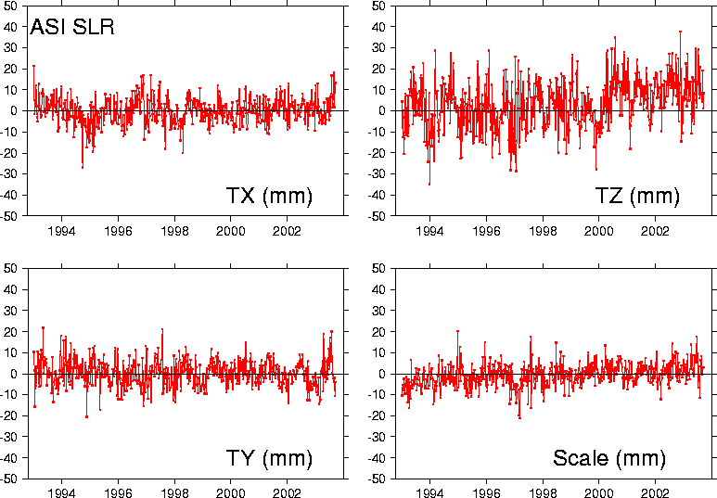

The epoch of the proposed weekly solutions was also considered. The current Pilot Project solutions use 28-day arcs beginning on Tuesday each week, which then provides enough time for the analysis and combinations groups to make available an ILRS EOP product for the IERS. However, it was noted that the ILRS combination product could be more readily combined with those of the other services if it is time-aligned to the GPS week; i.e., the seven-day data-span should begin at 0hrs Sunday and end at 24hrs on Saturday.

Recommendations
- The session heard that the AWG recommends that the analysis coordinators implement these two changes (7-day data arc, epoch aligned to GPS week) to the POS+EOP Pilot Project and proposes that the changes to the CfP take effect from mid-November 2003, via emails to the contributing groups.
- Still to be decided, by consultation between the analysis coordinators and IERS, is how best to provide a weekly, timely ILRS EOP product for the IERS rapid service.

Session 14. New approaches (Erricos Pavlis, Mark Torrence)

The chair reviewed first the state of the analysis working group's current and future plans and procedures. At the moment the Pilot Projects (PP) for the analysis of LAGEOS-1 and -2 and ETALON-1 and -2 SLR data in 28-day batches is completed, although the results for the ETALON case have not been fully validated and evaluated by a substantial number of ACs. The new approach adopted during the Koetzting workshop was also described: Complete the benchmark PP by the end of the year, and start the support of the EOP+STA PP with weekly arcs coincident with the definition of a GPS-week (i.e., Sunday 0h UTC to Saturday 24h UTC). Continued support of the traditional SLR customers (e.g., NEOS and JPL) was also adopted, with the use of a fixed datum (ITRF2000).

The chair presented a short example where LAGEOS data were used at JCET to estimate the location of the FTLRS at Chania, from a sparse SLR data set and independently, at CSR/UTEX, John Ries used a much stronger set of JASON SLR data to estimate the same location. The two positions were compared and found to agree within 2 cm or so. Suggestions from the floor hinted that we may be ripe enough to start including more targets in the process that produces the weekly products. The GFZ experience is that a simultaneous analysis of SLR and GPS data from CHAMP produces a far more robust and accurate set of EOP products. Werner Gurtner pointed out the on-going IGS LEO PP. The chair suggested that it may be worthwhile to pursue a joint PP in the near future. This will be a discussion point for the next AWG meeting.

The chair pointed out that there are several changes in the modeling, conventions, and standards areas where we need to focus our attention in order to meet the schedule for required alignment of our modus operandi with the newly adopted models, etc. It was also pointed out that part of the success of our work, especially if we adopt new approaches and include new targets in the near future, hinges on the timely and as accurate as possible adoption of target signature models for the SLR satellites (commonly known as Center of Mass (CoM) offsets). In the area of improved refraction models, the chair accepted an action item to make publicly available a routine that implements a new version for the computation of the Zenith Delay and the Mendes mapping function, applicable to all SLR-used wavelengths (i.e., from 355 nm to 1064 nm), with millimeter accuracy. In connection with this issue, the chair presented a new approach for the near real-time computation of refraction corrections on the basis of global geophysical fields derived from missions such as the AIRS instrument on the AQUA EOS platform. The automatic benefit of such an approach is that it will naturally account for any horizontal gradients in the atmosphere surrounding each tracking site. Additional action items were the clarification of adopted models for the tidally coherent signals in EOP and the geocenter. It was suggested that none of the ACs starts producing results with new models, prior to their official adoption by the AWG (to avoid confusion).

Finally, it was pointed out that under the newly adopted procedures, ACs should consult the ILRS web site, and in particular the QC reports, for up-to-date information on station yield/quality, and adjust accordingly their weighting scheme, with a minimum number of 10 NPs (L1 + L2) from each site over the 7 days as a ticket for accepting that site in the weekly solution.

Action Items:
- The AWG will discuss at its next meeting the possibility for additional PP to investigate the data-level combination of techniques.
- The new zenith delay model (Ciddor-Mendes) to be released as soon as the associated paper is submitted for publication, possibly by the end of 2003 (Mendes and Pavlis).
- The currently used by the ILRS community "background" models (according to IERS conventions) for tidally coherent signals in the geocenter and EOP to be reviewed and reported back to the AWG and IERS Conventions group (Pavlis).

Session 15. KHz ranging and its impact (Georg Kirchner, John Degnan)

John Degnan began the session by presenting an overview of kHz laser ranging including its advantages, special requirements, normal point computation, and performance expectations for the NASA SLR2000 system. At present, only two groups are working with kHz systems: GSFC (SLR2000) and Graz. KHz laser ranging systems take advantage of recently developed microchip and SESAM lasers, which are simpler, ultra-compact, and less expensive than mode-locked lasers for picosecond pulse generation and naturally operate at kHz frequencies. Since the oscillator output energies are orders of magnitude higher than that of mode-locked lasers, they require fewer amplifier stages, and can be designed without the need for high speed, high voltage electro-optic switches. Since the number of range returns per normal point can increase by about two orders of magnitude relative to conventional 5 to 10 Hz systems, the normal point precision can improve by over an order of magnitude and may allow meaningful two color measurements of differential atmospheric delay using high speed PMT’s or SPAD’s. Sample calculations for the photon-counting SLR2000 system ranging to LAGEOS in a Standard Clear atmosphere (23 km visibility) suggest about 60,000 successful ranges per two-minute normal point near zenith (25% return rate) and about 5000 per normal point at 20º elevation (2% return rate). Since the RMS of the LAGEOS impulse response is about 15 mm, the RMS precision of the centroid (normal point) would have a lower limit of 0.2 mm during acquisition and 0.05 mm near zenith. This “best case” calculation ignores any statistical broadening due to the system impulse response or the minimum timing resolution of the receiver. Differencing the centroids of the orbital residuals at two wavelengths with these kinds of statistical precisions may support mm accuracy two color measurements of the differential time of flight - at least at the higher elevation angles (but just barely).

Clearly, the higher repetition rate compensates for single pulse photon deficit and allows single pulse output flux to be reduced to eyesafe levels thereby eliminating the need for safety observers or aircraft radars. Furthermore, single photon range measurements are free of signal amplitude biases, and the orbit range residuals within a single normal point period are expected to reproduce the impulse response of the overall system (laser, satellite, and detector).

Special requirements of kHz systems include: kHz gating circuits and range gate generators; the use of event timers rather than time interval units due to multiple pulses in flight; more sophisticated ranging software required to extract the signal from the background noise and to link the proper return signal to each start pulse in computing the pulse time of flight; faster interfaces between the ranging hardware and system CPU; and more aggressive background noise reduction and fast receiver recovery times in the case of photon-counting systems.

Georg Kirchner then presented some exciting results obtained at Graz with their new 2 kHz laser (400 microjoules per pulse at 532 nm). After roughly two weeks of effort, Graz obtained more than 200,000 range measurements in a single LAGEOS pass (>45,000 per normal point) in general agreement with the theoretical expectations previously reported by John Degnan. More than 1 million measurements in a single Ajisai pass were also reported. Because of the very short pulsewidth of 10 psec, there is little electromagnetic interference between the various retroreflectors so that returns from individual cubes could be resolved on a number of targets. Georg also reported that satellite acquisition was easier at the high repetition rate and the system tracked down to 10º elevation, day or night.

Ivan Prochaska then reported on additional experiments to a ground target at 6 km distance which used the 2 kHz Graz system to measure the range jitter induced by atmospheric turbulence (0.4 mm) as well as atmospheric seeing (~2 arcseconds). He also reported on ESA-sponsored activities on a spaceborne altimeter for mapping extraterrestrial bodies (e.g., Mercury) from planetary orbit. (see also recent articles by John Degnan in J. Geodynamics, November 2002 and J. e&I Electrotechnik und Informationstechnik, April 2002, which consider a photon-counting global mapping mission at Mars). Finally, Karel Hamal reported on a new 2 kHz version of their Portable Picosecond Event Timer (P-PET).
Session 16. SLR 20000 (John Degnan)

SLR2000 is an autonomous and eyesafe photon-counting satellite laser ranging station with an expected absolute range accuracy better than one cm and a normal point (time-averaged) range precision better than 1 mm. The system will provide continuous 24 hour tracking coverage to an existing constellation of approximately two dozen artificial satellites equipped with passive retroreflector arrays. Replication costs are expected to be on the order of $1.5M per system, and the system will be about 75% less expensive to operate and maintain than current manned systems. Computer simulations have predicted a daylight tracking capability to retro-reflector equipped GPS (altitude 19,000 km) and lower satellites. Computer and hardware simulations have demonstrated the ability of our current correlation range receiver and auto-tracking algorithms to extract mean signals as small as 0.0001 photoelectrons per pulse from solar background noise during daylight tracking.

The SLR2000 system concept was first proposed in 1994], but significant funding for the SLR2000 project was not provided by NASA until August 1997. The first detailed overview of the SLR2000 system concept and proposed technical approach was presented at the 1997 Fall Europto Meeting in London, UK and has evolved with time. These periodic system level reviews as well as more detailed papers on individual subsystems, algorithms, and software packages can be found in the proceedings of the last three biannual International Workshops on Laser Ranging, which were held in Deggendorf, Germany in 1998; Matera, Italy in 2000; and Washington DC in 2002. The reader is referred to these earlier system overviews and to the workshop articles referenced herein for additional background and technical detail. The SLR2000 project also maintains a web site at:

http://cddisa.gsfc.nasa.gov/920_3/slr2000/slr2000.html

where additional SLR2000-related hardware and software publications and presentations are available online along with photos and test results for the various subsystems.

During the first two years of NASA funding, prototypes of several "enabling" components, without which the system is not feasible, were successfully developed. These include: (1) a sensitive, high speed, quadrant microchannel plate photomultiplier for simultaneous ranging and pointing correction; (2) oscillator-only and oscillator/amplifier versions of a microchip-laser based transmitter; (3) a "smart" meteorological station which includes an upgraded all-sky cloud sensor; (4) a multi-kHz rate range gate generator; and (5) a multi- kHz rate, 1 mm resolution event timer. Once the key specifications on these advanced components were largely met and system feasibility had therefore been established, attention then turned to the detailed engineering design and procurement of more conventional elements of the system such as the shelter and protective dome, arcsecond precision tracking mount, telescope, and optical transceiver. The principal challenge during this phase was to choose reliable but low cost approaches to meeting our technical requirements and goals. As of this writing, prototypes of the essential SLR2000 components and subsystems have been developed, successfully tested at the subsystem level, and integrated into the prototype system.

Field alignment and testing of the prototype has been underway at the Goddard Geophysical and Astronomical Observatory (GGAO) since shortly after the Washington workshop. Star calibrations had consistently been below 3.5 arcseconds RMS using an 18 element mount model and 50 stars, but very recent improvements have reduced the overall RMS error to 2.2 arcseconds. Factory and field tests of the tracking mount demonstrated a tracking precision (actual vs. command) of better than 1 arcsec for all but the highest angular velocity tracks. Within the limitations of the low-resolution (4.2 arc minute) star camera, the system appeared to track sunlit satellites in the field. Recent ground ranging tests to the calibration target are being evaluated, and the system is being prepared for actual satellite ranging tests during this calendar year. A Request for Proposals (RFP) for system replication is currently projected for late summer 2004. However, the funding, management, and manpower uncertainties currently being endured by the NASA SLR network put these schedule projections at some risk.

Beyond the development of the basic SLR2000, we have been investigating potential future upgrades and applications of the system. For example, one may be able to take advantage of bias-free photon-counting range measurements and kilohertz laser fire rates and difference the normal points (time-averaged data) at two wavelengths (nominally 532 and 355 nm) to compute the atmospheric refraction delay. This upgrade would require the addition of a UV wavelength channel to the receiver.

The feasibility of utilizing SLR2000 as an Earth station in a two-way laser transponder link for precise interplanetary ranging and time transfer has also been examined. Detailed mathematical models and operational scenarios have been developed and applied to a two-way Earth-Mars link.

NASA headquarters has also directed GSFC to work with the Jet Propulsion Laboratory (JPL) in investigating the feasibility of using SLR2000 as the ground terminal in a space-to-ground laser communications link while simultaneously ranging to retroreflectors onboard the spacecraft. The motivation for initiating this activity comes from an emerging suite of new Earth sensors which require substantial information bandwidths for high speed data transfer to the ground. These include hyperspectral imagers, Interferometric Synthetic Aperture Radars (In-SAR), and 3D imaging lidars based on our photon-counting techniques. SLR2000 is already designed to perform the majority of field operations needed for an automated laser communications station and has a sufficiently large telescope to accommodate high bandwidths transmitted from Earth orbit. For example, it automatically assesses local weather and cloud cover conditions and performs necessary system and personnel health and safety functions. In addition, SLR tracking provides a highly accurate orbit for rapid spacecraft acquisition, independent confirmation of target satellite acquisition via the retroreflector returns, and a visible beacon for the spaceborne communications terminal to lock onto. A simple wavelength splitter within the SLR2000 optical transceiver would divert the incoming communications photons to a separate lasercom receiver. Recent analyses conducted in support of some proposed NASA missions has indicated that SLR2000 can support several Gbps lasercom links from geostationary satellites and several tens of Mbps over lunar distances with about 2 watts of transmitter power at the remote terminal. It is hoped that such a diversification of SLR2000 functions will attract new users and additional funding for a global multifunction SLR2000C (for Communications) network.

Session 17. Automation (Ben Greene, Werner Gurtner)

Topics for Automation

The following list contains topics that can be subject for automation at a tracking station:

- Mount model generation (star calibration)
  - generation of a list of well-distributed catalogued stars
  - coarse telescope pointing
  - CCD imaging and subsequent image processing or fine pointing using some star sensor
  - computation of the mount model
- Prediction handling
  - extraction of respective e-mail messages or ftp downloads from data centers
  - data base maintenance)
- Satellite passes
  - generation of pass lists for a certain time period (e.g., one week)
  - ephemerides for passes to be tracked
  - observation and calibration schedule (proposal for observers or schedule for automated operation)
  - a priori sun interference handling
  - horizon masks
- General power-up of station (e.g., laser)
- Start of tracking
  - Telescope
  - laser
  - dome
  - electronics
  - optical components
  - pass and calibration schedule
- Satellite acquisition
  - search algorithms (along-track, spirals)
  - signal detection (signal/noise separation)
  - time bias computation
  - range gate/window settings
- Track keeping: Keep laser beam on target during the tracking
  - time bias adjustment
  - fine tuning of pointing
  - signal level control
- Pass interleaving
  - using a priori schedule
  - realtime adjustment of schedule according to current conditions (weather conditions such as cloud coverage, used acquisition times, prediction quality,…)
- Stop tracking
  - put telescope to park state
  - close dome
  - switch off laser (or certain components only)
  - switch off certain electronic components
- Post-processing
  - apply calibration values
  - data cleaning (elimination of noise returns, outliers)
  - normal point generation
  - reformating (quick look exchange format
  - data submission to data center
  - reporting and protocols
- General power-down of station

Status of Automation in the Network

Many stations have realized at least some degree of automation. An example (Matera MLRS) was explained by G. Bianco.

However, there are currently two systems only with the capability of around-the-clock automation, i.e. completely unattended operation for days or weeks in a row:

- Mount Stromlo: Realized for the station destroyed in the bush fires early 2003, again planned for the replacement station currently under construction. The observation scenario would be prepared for a week ahead of time. As the system operates in a sealed dome there are no provision taken to account for bad weather: The system just follows the preprogrammed schedule.

- SLR-2000: The system is still under development. John Degnan explained the current status of various subsystems needed for the realization of a fully automated system. The system will include a cloud monitor and a rain sensor, the former allowing for the optimization of the tracking schedule in real time by taking into account the actual cloud distribution.

Zimmerwald station is run in a fully automated mode at about 20 percent of the time, mainly to extend the shifts or to bridge gaps between two shifts. Thus a 24-hour coverage can usually be realized with two shifts per day. The data yield during the automated operation is comparable to the interactive mode.

ILRS Workshop

Kötzting, Germany

October 28 - 31, 2003

List of Participants

Last Name | First Name | E-Mail
Altamimi | Zuheir | altamimi@ensg.ign.fr
Appleby | Graham | graham.appleby@nerc.ac.uk
Biancale | Richard | biancale@calc-gen3-ci.cst.cnes.fr *
Bianco | Giuseppe | giuseppe.bianco@asi.it
Brandl | Nikolaus | nikolaus.brandl@bkg.bund.de
Brunner | Fritz | sandra.schmuck@tugraz.at
Carman | Randall | moblas@midwest.com.au
Carter | David | David.L.Carter@nasa.gov
Combrinck | Ludwig | ludwig@hartrao.ac.za
Combrink | Attie | attie@hartrao.ac.za
Davila | Jose Martin | mdavila@roa.es
Dawson | John | john.dawson@ga.gov.au
Degnan | John | john.degnan@sigmaspace.com
Fumin | Yang | yangfm@center.shao.ac.cn
Galkin | Yury | galkin@mgul.ac.ru
Garate | Jorge | jgarate@roa.es
Gibbs | Philip | pgib@nerc.ac.uk
Govind | Ramesh | Ramesh.Govind@ga.gov.au
Greene | Ben | bengreene@compuserve.com
Grunwaldt | Ludwig | grun@gfz-potsdam.de
Guaitiao | Cesar | stefan.riepl@bkg.bund.de
Gurtner | Werner | gurtner@aiub.unibe.ch
Hamal | Karel | prochazk@mbox.cesnet.cz
Haufe | Karl-Heinz | karl-heinz.haufe@bkg.bund.de
Herbetz | Stefan | stefan.herbertz@bkg.bund.de
Herold | Guenther | guenther.herold@bkg.bund.de
Husson | Van | van.husson@honeywell-tsi.com
Ihde | Johannes | johannes.ihde@bkg.bund.de
Johannsen | Ingo | ingojohannsen@highqlaser.at
Kirchner | Georg | kirchner@flubpc04.tu-graz.ac.at
Koenig | Rolf | koenigr@gfz-potsdam.de
Koidl | Franz | koidl@flubpc04.tu-graz.ac.at
Kunimori | Hiroo | kuni@crl.go.jp
Lauber | Pierre | lauber@wettzell.ifag.de
Luceri | Vincenza | cinzia.luceri@asi.it
Maeda | Maki | maeda.maki@jaxa.jp
Mareyen | Maria | mamy@bkg.bund.de *
Motz | Rudolf | rudolf.motz@bkg.bund.de
Müller | Horst | mueller@dgfi.badw.de
Nurutdinov | Kostyantyn | nurut@mail.ru *
Otsubo | Toshimichi | otsubo@crl.go.jp
Pavlis | Erricos | epavlis@JCET.umbc.edu
Pearlman | Mike | mpearlman@cfa.harvard.edu
ILRS Workshop

Kötzting, Germany

October 28 - 31, 2003

List of Participants (Continued)

Last Name | First Name | E-Mail
Pierron | Francis | Francis.pierron@obs-azur.fr
Prochazka | Ivan | prochazk@mbox.cesnet.cz
Ramirez | David | stefan.riepl@bkg.bund.de
Richter | Bernd | richter@iers.org
Riepl | Stefan | stefan.riepl@bkg.bund.de
Rothacher | Markus | rothacher@bv.tum.de
Salminsh | Kalvis | kalvis@lanet.lv
Schillak | Stanislaw | sch@cbk.poznan.pl
Schlicht | Anja | anja.schlicht@bkg.bund.de
Schlüter | Wolfgang | wolfgang.schlueter@bkg.bund.de
Schreiber | Ulrich | schreiber@wettzell.ifag.de
Seemueller | Wolfgang | seemueller@dgfi.badw.de
Tatevyan | Ruben | gleb@geod.ru
Torrence | Mark | mtorrenc@magus.stx.com
Utzinger | Johannes | johannes.utzinger@aiub.unibe.ch
Wilkinson | Matthew | Matwi@nerc.ac.uk
You | Zhao | youzhao@public.cc.jl.cn

* Attended AWG only

