Supplementary Figure 1: Translational proportions for all therapies (neglecting development time).
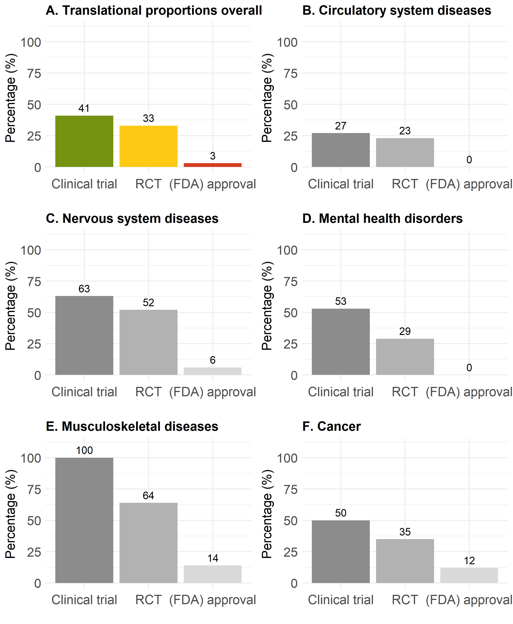
Proportions of translation from animals to any clinical study (green), to an RCT (yellow), or to (FDA) approval (red) overall (A), for circulatory system diseases (B), for neurological diseases (C), for mental health disorders (D), for musculoskeletal diseases (E), and for cancer (F).
The data underlying this figure can be found on https://osf.io/frjm4 (Sheet: Translation). The code underlying this figure can be found on https://osf.io/9fgru.
Abbreviations: RCT, randomized controlled trial.

