# Charitable Deductions

# Designations and Acknowledgements

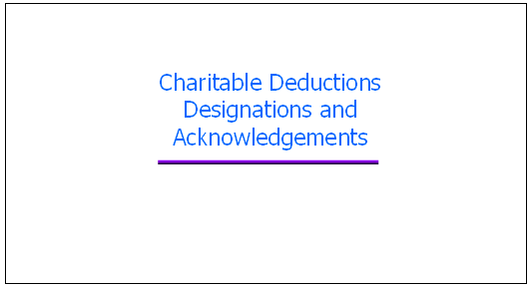

Welcome to Charitable Deductions Designations and Acknowledgements.

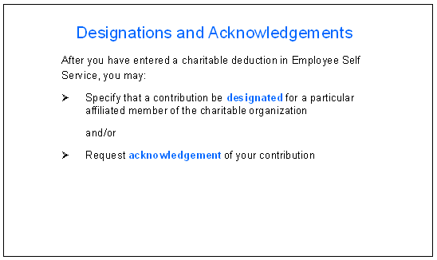

After you have entered a charitable deduction in Employee Self Service, you may specify that a contribution be **designated** for a particular affiliated member of the charitable organization and/or request **acknowledgement** of your contribution.

Designations and acknowledgements are optional.
If you want to specify designations or request acknowledgements, follow these instructions.


Designations and acknowledgements are **optional**.

If you want to specify designations or request acknowledgements, follow these instructions.

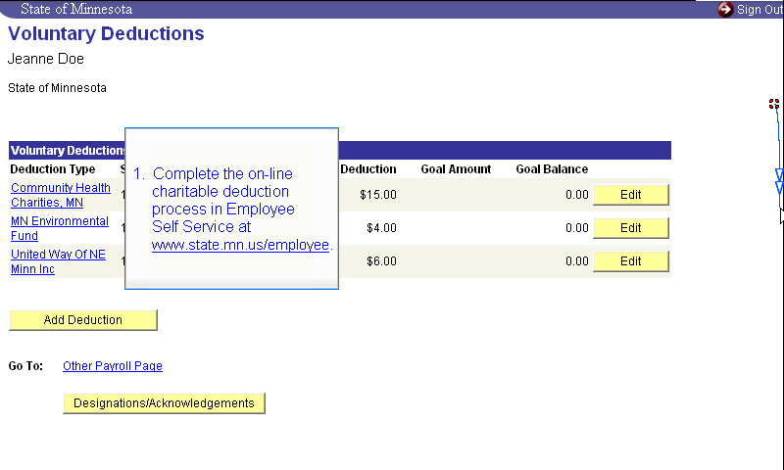

First, complete the on-line charitable deduction process in Employee Self Service

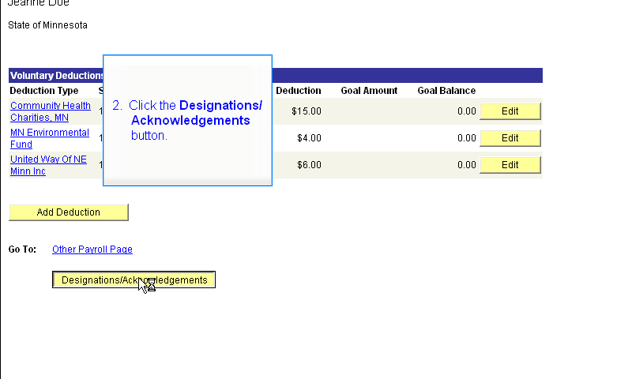

and click the Designations/Acknowledgements button.

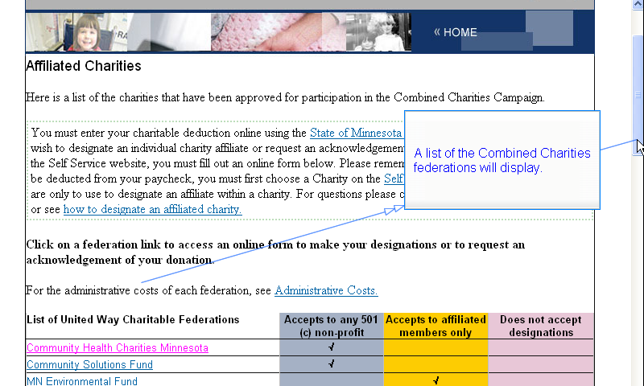

A new web page will display, listing all of the Combined Charities federations.

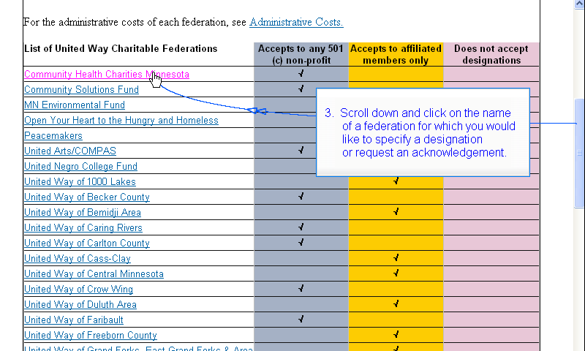

Scroll down and click on the name of a federation for which you would like to specify a designation or request an acknowledgement. This is one of the federations for which you have already entered a charitable deduction in Employee Self Service.

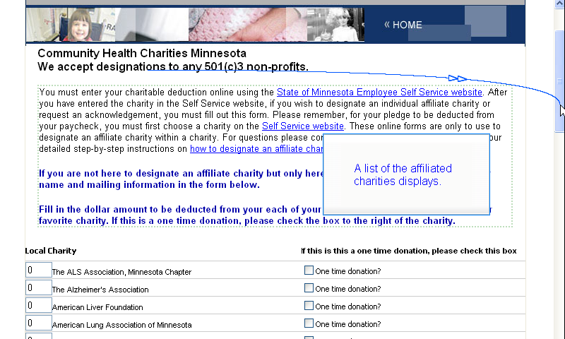

A list of the affiliated charities displays.

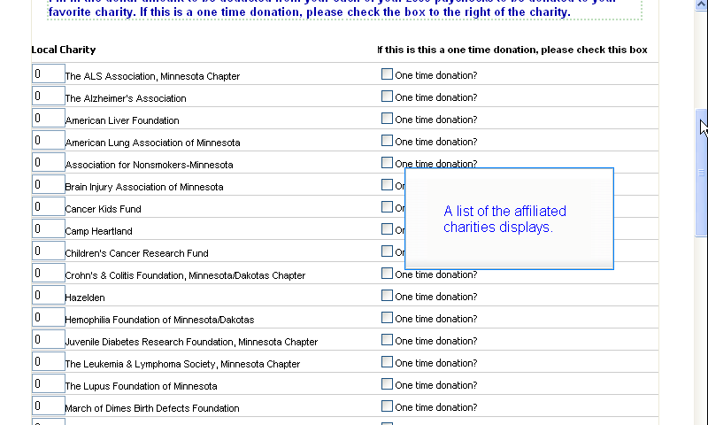

Scroll down to see the list. These charities are affiliated with the federation you selected.

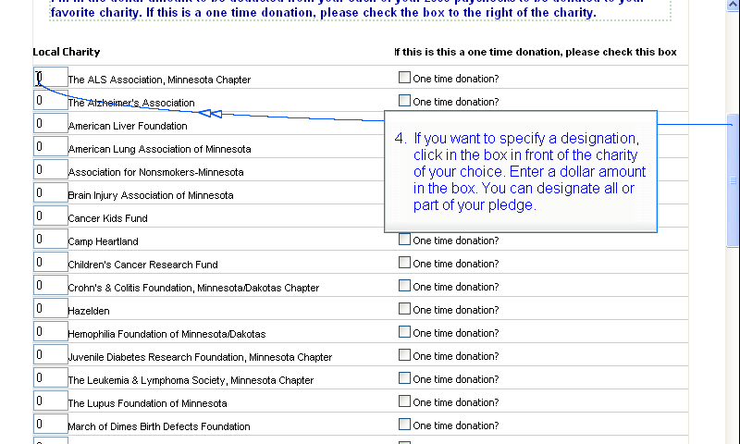

If you want to specify a designation, click in the box in front of the charity of your choice. Enter a dollar amount in the box. You can designate all or part of your pledge.

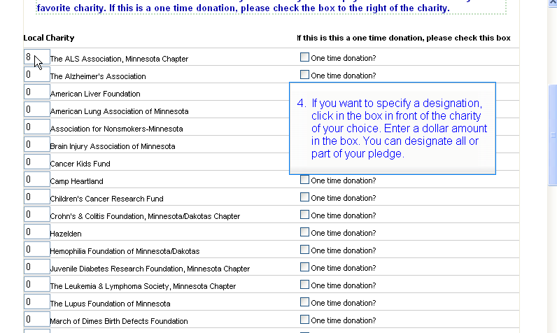

In this example, 8 dollars are designated for the ALS Association

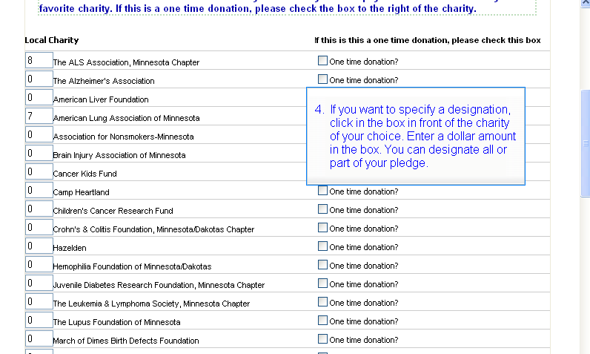

and 7 dollars are designated for the American Lung Association.

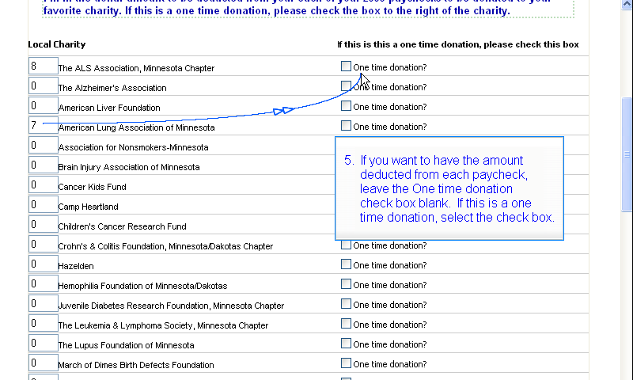

If you want to have the amount deducted from each paycheck, leave the One time donation check box blank. If this is a one time donation, select the check box.

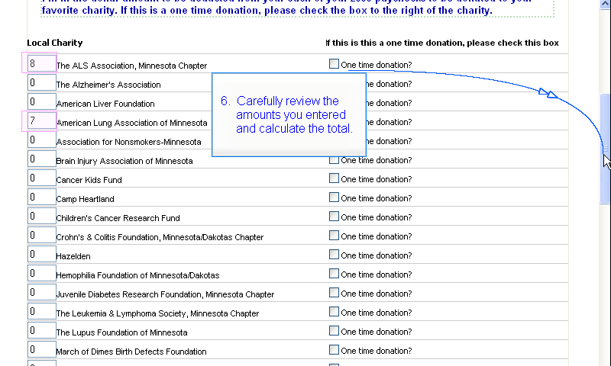

Carefully review the amounts you entered and calculate the total.

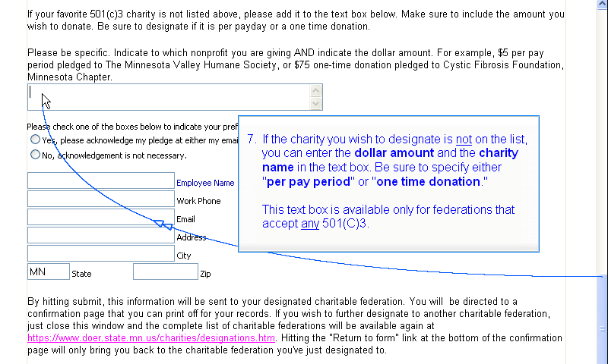

If the charity you wish to designate is not on the list, you can enter the dollar amount and the charity name in the text box. Be sure to specify either "per pay period" or "one time donation." This text box is available only for federations that accept any 501(C)3.

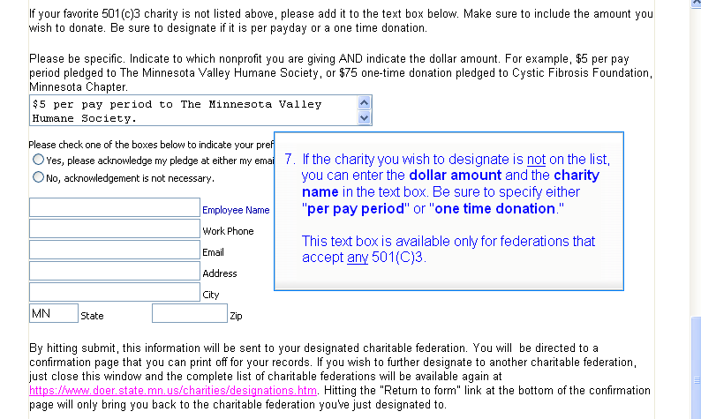

For example: $5 per pay period to The Minnesota Valley Humane Society. Notice that you need to include three pieces of information: the amount, either “per pay period” or “one time donation”, and the charity name.

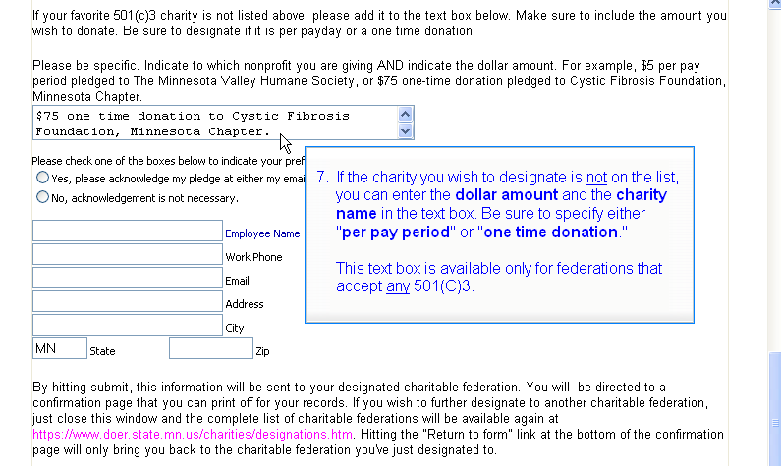

Here’s another example: $75 one time donation to Cystic Fibrosis Foundation, Minnesota Chapter.

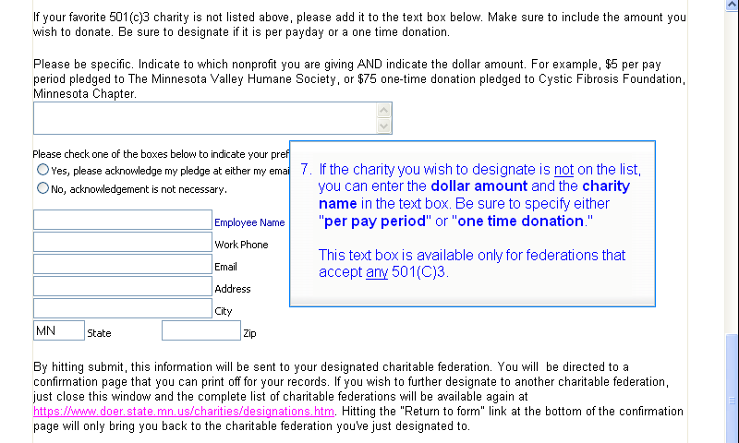

Of course, if the charities you wish to designate **are** on the list, you leave the text box blank.

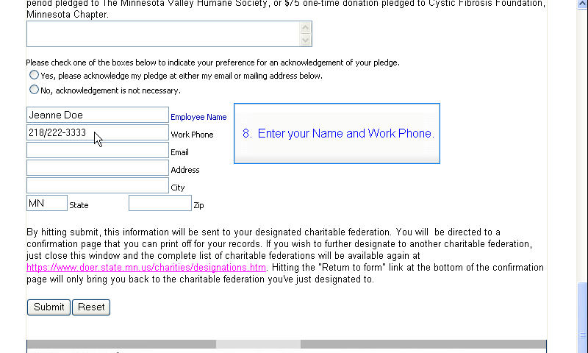

Enter your Name and Work Phone.

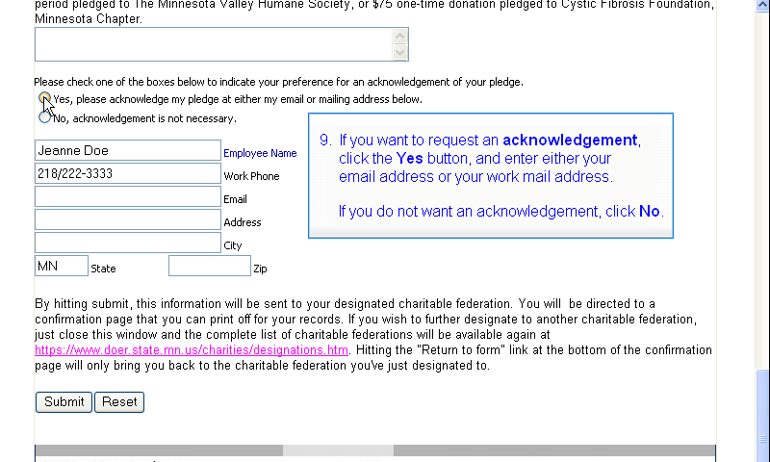

If you want to request an acknowledgement, click the Yes button

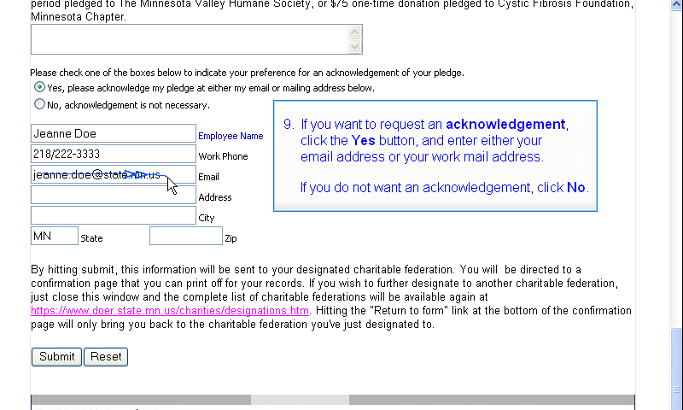

and enter either your email address or your work mail address.

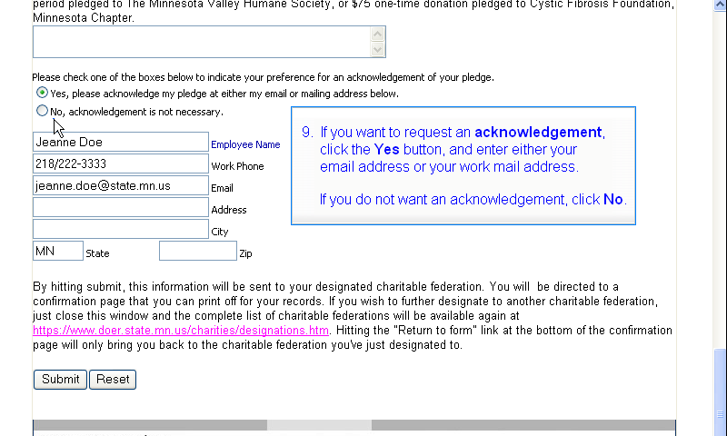

If you do not want an acknowledgement, click the No button.

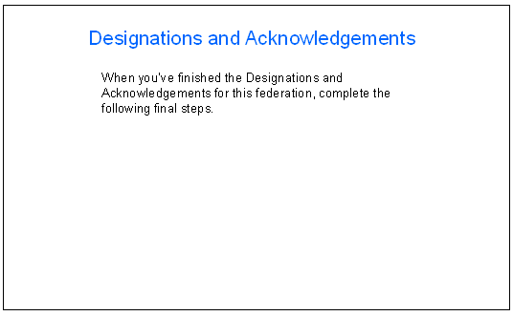

When you’ve finished the Designations and Acknowledgements for this federation, complete the following final steps.

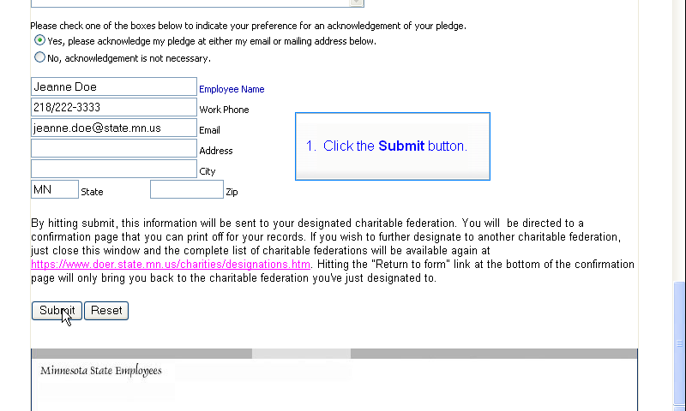

First, click the Submit button.

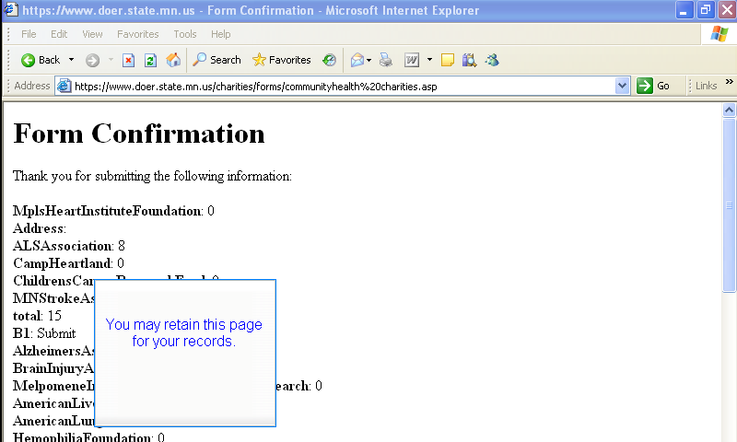

A confirmation page will display.

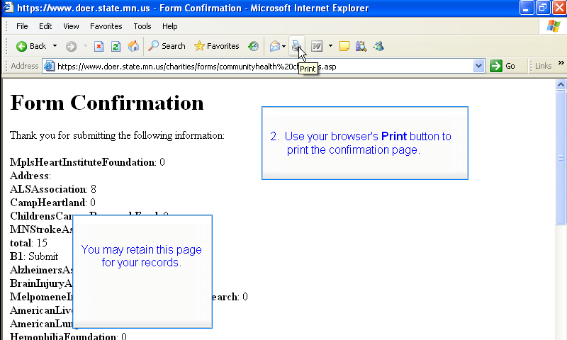

Use your browser's Print button to print the confirmation page.

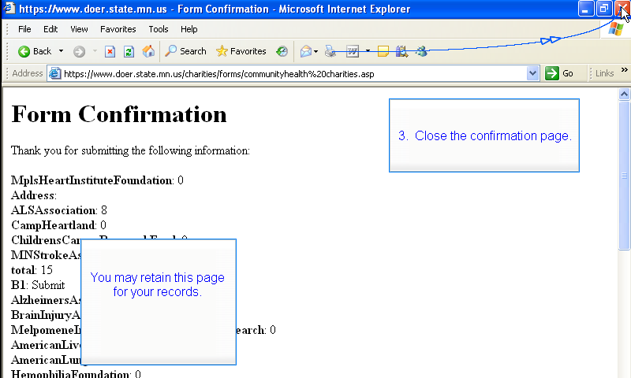

Close the confirmation page.

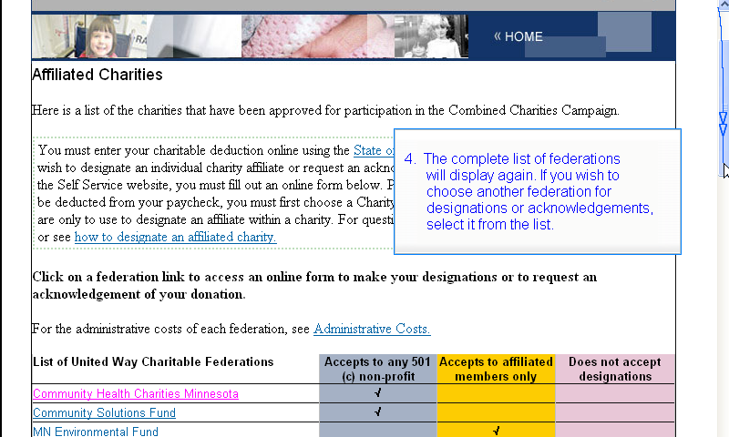

The complete list of federations will display again.

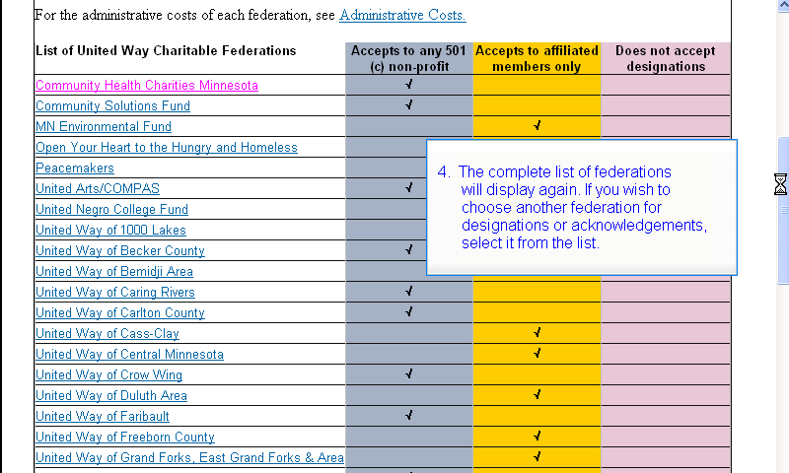

If you want to choose another federation for designations or acknowledgements, select it from the list.

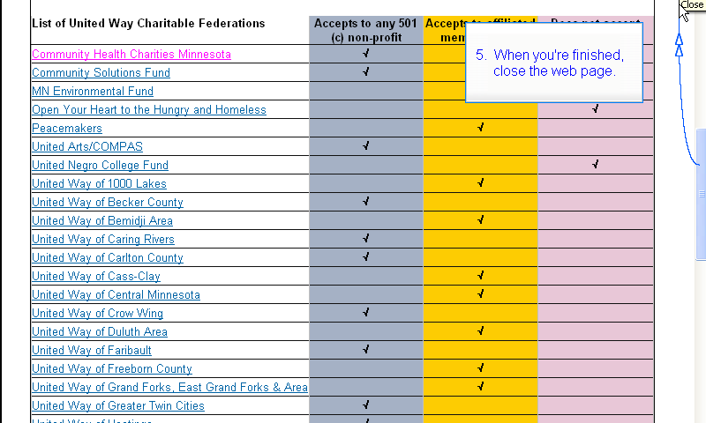

When you're finished, close the web page.

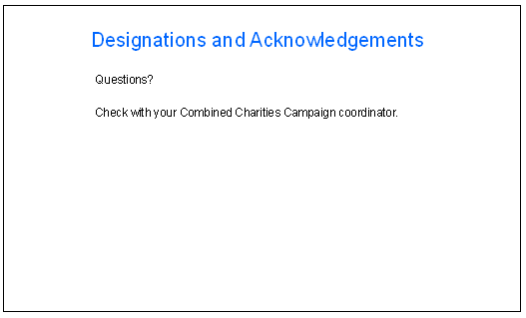

If you have questions, check with your Combined Charities Campaign coordinator.

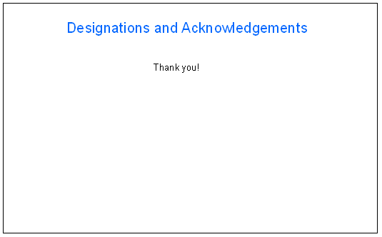

This concludes the presentation. Thank you!