Principles of Retardant Application

• Determine tactics direct or indirect based on fire size-up and resources available.

• Establish an anchor point and work from it.

• Use the proper drop height.

• Apply proper coverage levels.

• Drop downhill and down-sun when feasible.

• Drop into the wind for best accuracy.

• Maintain honest evaluation and effective communication between the ground and air.

• Use direct attack only when ground support is available or extinguishment is feasible.

• Plan drops so they can be extended or intersected effectively.

• Monitor retardant effectiveness and adjust its use accordingly.

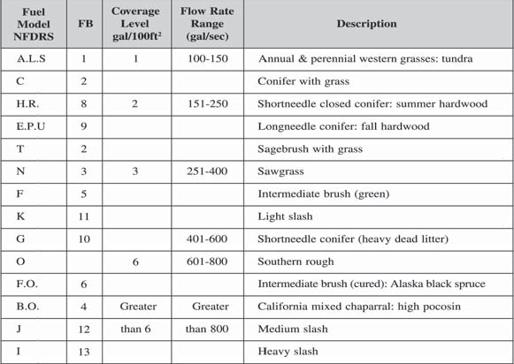
Retardant Coverage Levels

