WFCS Fire Chemical Web Site

http://www.fs.fed.us/rm/fire/wfcs/index.htm

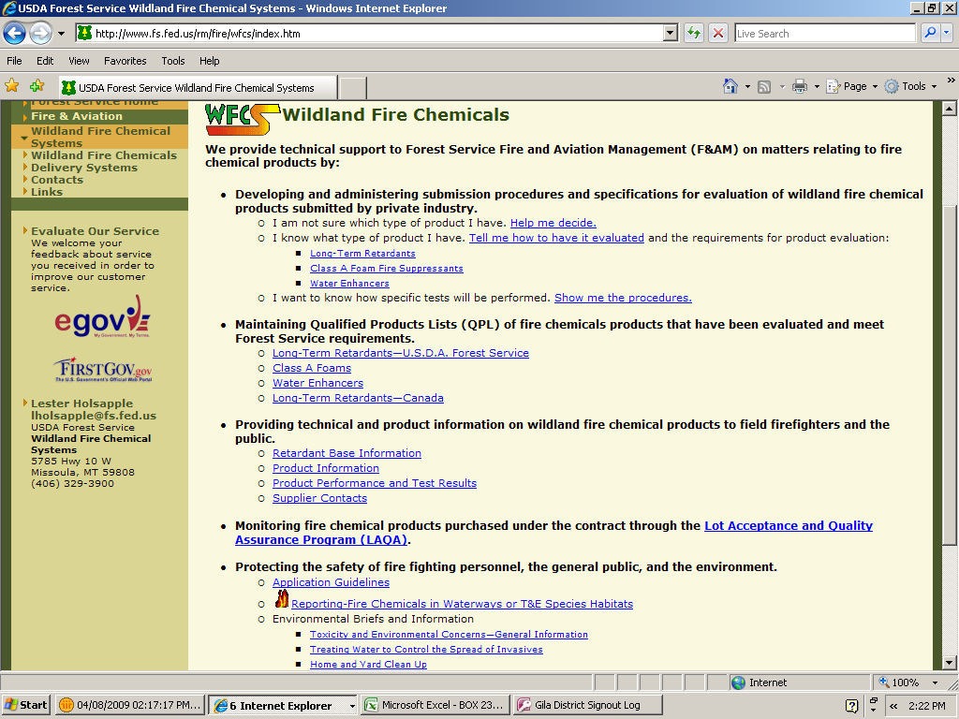
Click on this link to find information about the reporting requirements, instructions, forms and the FWS Species of Concern list.

Guidelines for aerial delivery of retardant or foam near waterways.

(300-foot buffer zone)

See Report Form Below

INTERAGENCY WILDLAND FIRE CHEMICAL REPORTING FORM
(and INSTRUCTIONS)
1. Incident Name: | 2. Date/Time of Occurrence:
3. Date/Time of Discovery: | 4. GPS Location (decimal °): Lat: Long:
5. Physical Location of Occurrence – Unit Name (Forest, District, etc), waterway and any other landmark names:

6. Type of Fire Chemical: Retardant Foam Water Enhancer (Gel)
7. Name of Fire Chemical:
8. Method of Exposure: Large Airtanker SEAT Helibucket Helitanker Ground
9. Occurrence Was: Accidental (aerial) Accidental (ground) Exception to 2000 Guidelines
10. Description of Fuel Coverage at Site: Open Light Fuels Brush Open Timber/Grass
(check all that apply) Timber/Brush Heavy Timber/Closed Canopy Slash
11. Physical Description of Site (steep, level, rocky, high organic soil, etc.):

12. Description of Chemical Coverage on Site: Light Mist Spotty Continuous Puddles
13. Extent of Chemical Coverage: Limited Coverage Scattered Coverage Widespread Coverage
14. Ground Spill (Approx. # of Gallons): Aerial Drop (% of Load Dropped - Full,1/2,1/4,etc) :
15. Approximate Size of Total Area Affected by Occurrence: Length ft. Width ft.
(NOTE: If reporting chemicals in a waterway, or the 300’ buffer zone, please complete #16, #17 & #18 below. Otherwise, skip to #19.)
16. Did Chemical Enter the Waterway: Yes No If Yes, Estimated Amount: gal. (or) %
17. Approx. Size and Depth of Waterway at Site (in feet): Length Width Depth
18. Description of Waterway: Stream River Pond Lake Other (list)
19. Name(s) of any Potentially Affected TES Species: (include ESU/DPS designation) |  | 20. Orientation & Extent of Application to Waterway and/or T&E Species Terrestrial Habitat (see form directions below):
21. Assessment of the Direct and Indirect Environmental Effects of the Wildland Fire Chemical (attach photos and maps if available):

22. Additional Comments:

23. Report of Fire Chemical Application made by (include unit/incident position, email address and phone #):

24. Date and Time Reported:

COMPLETING THE FIRE CHEMICAL REPORTING FORM

Use this form for reporting any aerial application of retardant, foam or water enhancer (gel) in a waterway or within the 300-foot buffer area; or when a transportation accident results in a spill of a wildland fire chemical into a waterway or within the 300-foot buffer; or when ground resources apply a wildland fire chemical that enters, or has potential to enter a waterway; or when applied on USFS administered lands in the habitats of the 45 Threatened & Endangered Species (TES) identified by the US Fish & Wildlife Service (USFWS) as being the most vulnerable to retardant, regardless of the 300’ waterway buffer.

Waterway defined: “Any body of water including lakes, rivers and ponds whether or not they contain aquatic life.”

Please complete the form as accurately as possible. If unsure of the answer to any question write “Unknown” in the applicable block. Submit the completed form to the host unit Agency Administrator and a copy to the Wildland Fire Chemicals System (WFCS) program at the Missoula Technology and Development Center (MTDC). The information can be sent via fax, hard copy mail, or email. This form may also be used by the local unit for the initial reporting to the appropriate regulatory agencies and specialists within the local jurisdiction. Note: if the agency administrator determines that there have been adverse effects to any aquatic TES within the 300 foot buffer, then emergency consultation requirements must be followed with the USFWS or the local National Marine Fisheries Service.

FAX for WFCS: (406) 329-4763

Mailing Address: WFCS, MTDC
5785 Highway 10 West
Missoula, MT 59808

Questions about the form: WFCS Chemical Reporting: 406-329-4859
(or) WFCS Program Leader: 406-829-6761

E-mail the form to: szylstra@fs.fed.us and
asuter@fs.fed.us

Form Instructions:

1. Incident Name: Self-explanatory

2. & 3. Date and Time of Occurrence/Discovery: Provide the date and time of the event if known, or the date and time of its discovery.

4. GPS Location: Record the latitude and longitude in degrees decimal (eg. 43 21.89 x 116 72.67)

5. Physical Location of Occurrence: List the drainage name(s), landmark name if applicable, and names of all known bodies of water affected. Include the Forest, District and/or Resource Area name.

6. Type of Fire Chemical: List whether retardant, foam or gel if known.

7. Name of Fire Chemical: Provide the product name of the wildland fire chemical if known.

8. Method of Exposure: Record the application method used in the delivery of the wildland fire chemical, either Large Airtanker (includes Very Large Airtanker), SEAT, helicopter bucket, helitanker or ground system.

9. Occurrence Was: State if the application was an accidental aerial application or an accidental transport application (due to a tanker truck or some other type of land delivery mishap) or by an exception to the 2000 “Guidelines for Aerial Delivery of Retardant or Foam Near Waterways” (exception is also found in the Interagency Standards for Fire and Fire Aviation Operations). If discovering the exposure after the fact, note that on the form.

10. Description of Fuel Coverage at Site: Self-explanatory

11. Physical Description of Site (steep, level, rocky, high organic soil, etc.): Self-explanatory

12. Description of Chemical Coverage on Site: Check the one that best describes the over-all coverage across the site area. Light Mist: self-explanatory. Spotty: ground & vegetation is covered w/chemical spotting, but not continuous chemical present. Continuous: chemical application is heavy enough that there is no longer individual spotting of chemicals. Puddles: chemical application is heavy enough that there are standing puddles present on the ground and/or vegetation.

13. Extent of Chemical Coverage: Check the coverage that best describes the over-all application within the 300’ waterway buffer or the TES habitat.

14. Ground Spill / Aerial Drop: For a transportation accident, estimate the number of gallons spilled and note if the gallons spilled are for concentrate or mixed product. For an aerial drop, state the % of the load dropped by the aircraft into the affected area, if known. The tanker pilot, lead plane or ATGS may have that info if available.

15. Approximate Size of Total Area Affected by Occurrence: Self-explanatory

16. Did Chemical Enter the Waterway: If yes, give your best estimate on the number of gallons that entered the waterway. If an aerial drop, give your best estimate of the drop percentage that impacted the waterway (e.g. 5%, 10%, etc.)

17. Approx. Size and Depth of Waterway at Site: If chemical entered the waterway, give approximate average in feet of the length, width and depth of waterway area affected by the occurrence

18. Description of Waterway (if applicable): Check as many as apply. “Other” could include canals, marshes and springs. If a body of water is present, it could also include riparian areas and intermittent streams.

19. Name(s) of any Potentially Affected T&E Species: for Waterway or terrestrial T&E species; include ESU (evolutionarily significant unit) and DPS (distinct population segment) name, if applicable.

20. Orientation & Extent of Application to Waterway and/or T&E species Terrestrial Habitat: If applicable, for Waterway T&E species or non-waterway habitats of the 45 T&E species identified in the FWS Biological Opinion, give the orientation of the drop or spill proximity to the waterway and/or terrestrial habitat. For example, if the stream runs E-W, was the drop/spill parallel (E-W) to, perpendicular (N-S) to, or angled (NW-SE) across the waterway. Which part of the drop/spill appeared to enter waterway (middle, end, all)? You may submit a map with the affected area drawn in.

21. Assessment of the Direct and Indirect Environmental Effects of the Wildland Fire Chemical: Provide information concerning the impact to the waterway, buffer zone, and if applicable, the TES and/or habitat area. Provide the names of any affected species. Direct impacts include factors like dead aquatic species, if a TES plant is completely covered, if the ground in the area is covered, etc. An example of indirect impacts would include the prevalence of fire chemicals in the area of a TES, but the chemicals are not touching or in close proximity to the species.

22. Additional Comments: Provide any other relevant information. This may include contributing factors like visibility issues, malfunctioning equipment, the use of fire chemicals being necessary for the protection of life and property or the use of chemicals potentially prevented more severe resource damage to the watershed/habitat than occurred from the chemical application itself.

23. Report of Fire Chemical Application made by: Self-explanatory

24. Date and Time Reported: Self-explanatory

