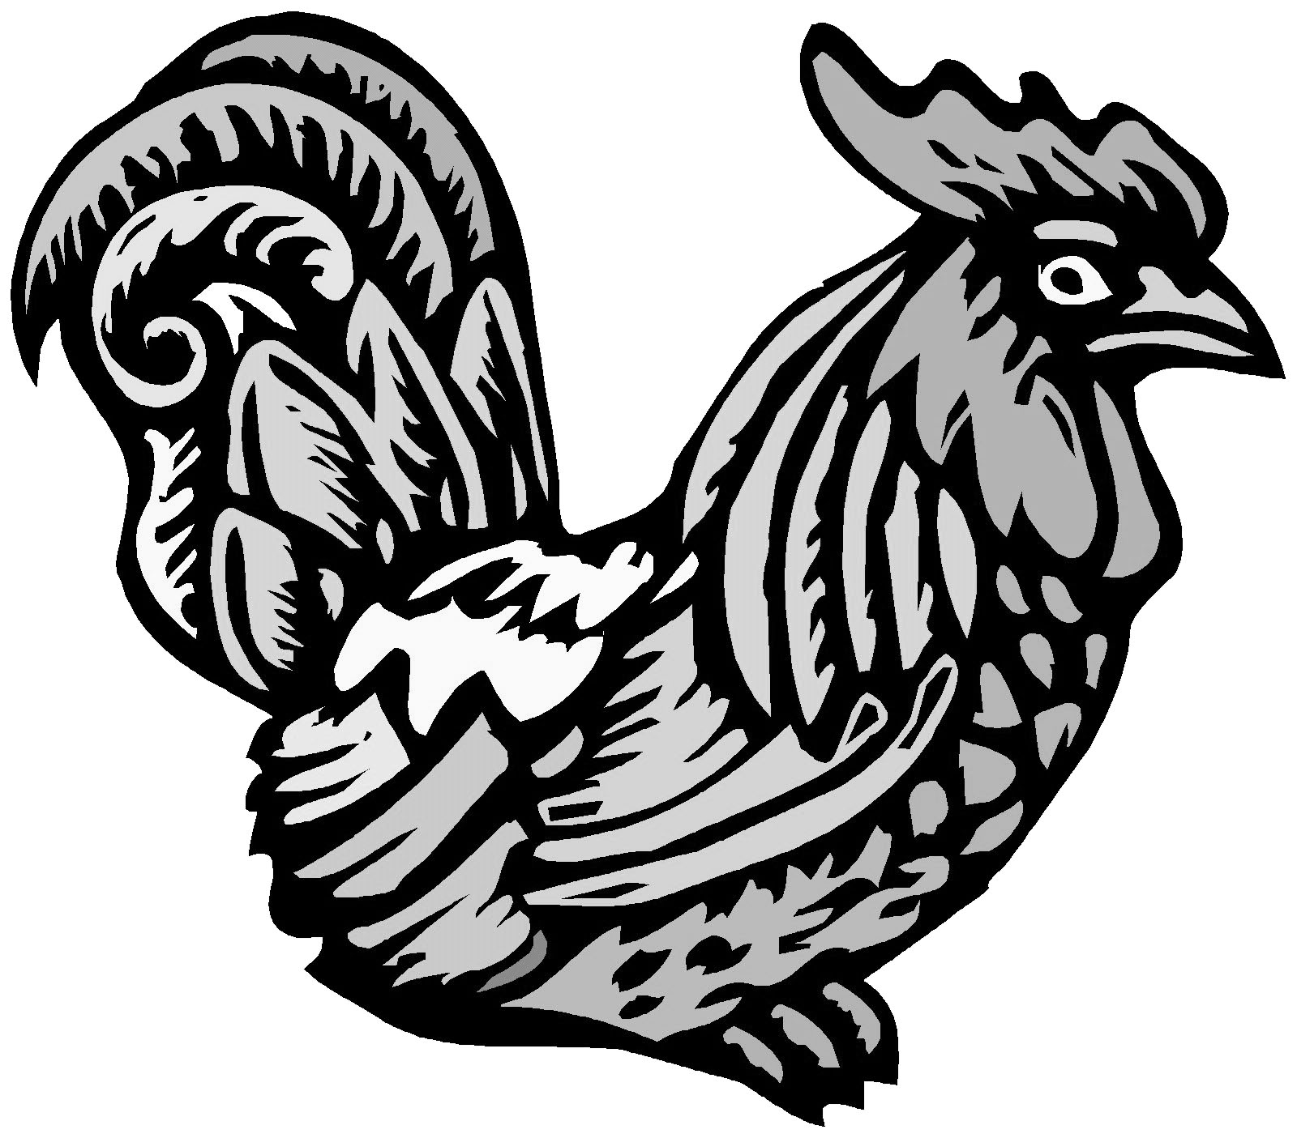
Exotic Newcastle Disease in Poultry/Birds
A serious poultry disease that primarily affects chickens may be present in this area. If your birds become ill or die, or if you are aware of any neighbor’s birds that may be affected, please call us immediately at 702-515-5200. We will arrange for a free veterinary evaluation of your bird.
To help protect your birds from this serious threat, please take the following precautions:
- Check your birds daily for signs of illness and call us immediately if they become ill.
- Keep your birds at home; do not move them to any other location.
- Don’t visit live bird markets as the disease may be present at these locations, and it can be transported back to your birds.
- Funds are available to purchase flocks diagnosed with this disease.
- This disease does not pose a threat to human health and does not affect the safety of poultry and egg products.

If you have any questions or require assistance in testing your birds please call us at
702-515-5200

