Your Local Council Name

Homeowner’s Checklist

How to make your home Fire Safe

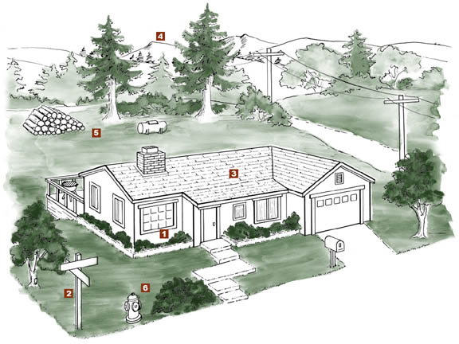

Your Local Council Name
Your Address
Your City, Your State, Your Zip Code
Your Phone contact
Your internet/e-mail info

OUTSIDE

1 Design/Construction
__ Consider installing residential sprinklers
__ Build your home away from ridge tops, canyons and areas between high points on a ridge
__ Build your home at least 30-100 feet from your property line
__ Use fire resistant materials
__ Enclose the underside of eaves, balconies and above ground decks with fire resistant materials
__ Try to limit the size and number of windows in your home that face large areas of vegetation
__ Install only dual-paned or triple-paned windows
__ Make sure that electric service lines, fuse boxes and circuit breaker panels are installed and maintained as prescribed by code
__ Contact qualified individuals to perform electrical maintenance and repairs
2 Access
__ Identify at least two exit routes from your neighborhood
__ Construct roads that allow two-way traffic
__ Design road width, grade and curves to allow access for large emergency vehicles
__ Construct driveways to allow large emergency equipment to reach your house
__ Design bridges to carry heavy emergency vehicles, including bulldozers carried on large trucks
__ Post clear road signs to show traffic restrictions such as dead-end roads, and weight and height limitations
__ Make sure dead-end roads, and long driveways have turn-around areas wide enough for emergency vehicles
__ Construct turnouts along one-way roads
__ Clear flammable vegetation at least 10 feet from roads and five feet from driveways
__ Cut back overhanging tree branches above roads
__ Construct fire barriers such as greenbelts
__ Make sure that your street is named or numbered, and a sign is visibly posted at each street intersection
__ Make sure that your street name and house number are not duplicated elsewhere in the county
__ Post your house address at the beginning of your driveway, or on your house if it is easily visible from the road
3 Roof
__ Remove branches within 10 feet of your chimney and dead branches overhanging your roof
__ Remove dead leaves and needles from your roof and gutters

__ Install a fire resistant roof. Contact your local fire department for current roofing requirements
__ Cover your chimney outlet and stovepipe with a nonflammable screen of 1/2 inch or smaller mesh
4 Landscape
__ Create a "defensible space" by removing all flammable vegetation at least 30 feet from all structures
__ Never prune near power lines. Call your local utility company first
__ Landscape with fire resistant plants
__ On slopes or in high fire hazard areas remove flammable vegetation out to 100 feet or more
__ Space native trees and shrubs at least 10 feet apart
__ For trees taller than 18 feet, remove lower branches within six feet of the ground
__ Maintain all plants by regularly watering, and by removing dead branches, leaves and needles
__ Before planting trees close to any power line contact your local utility company to confirm the maximum tree height allowable for that location
5 Yard
__ Stack woodpiles at least 30 feet from all structures and remove vegetation within 10 feet of woodpiles
__ Locate LPG tanks (butane and propane) at least 30 feet from any structure and maintain 10 feet of clearance
__ Remove all stacks of construction materials, pine needles, leaves and other debris from your yard
__ Contact your local fire department to see if open burning is allowed in your area; if so, obtain a burning permit
__ Where burn barrels are allowed, clear flammable materials at least 10 feet around the barrel; cover the open top with a non-flammable screen with mesh no larger than 1/4 inch
6 Emergency Water Supply
__ Maintain an emergency water supply that meets fire department standards through one of the following:
• a community water/hydrant system
• a cooperative emergency storage tank with
neighbors
• a minimum storage supply of 2,500 gallons on your property
__ Clearly mark all emergency water sources
__ Create easy firefighter access to your closest emergency water source
__ If your water comes from a well, consider an emergency generator to operate the pump during a power failure

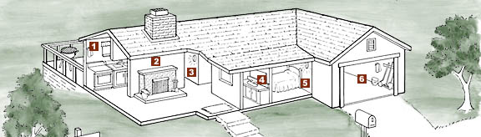

INSIDE

1 Kitchen
__ Keep a working fire extinguisher in the kitchen
__ Maintain electric and gas stoves in good operating condition
__ Keep baking soda on hand to extinguish stove-top grease fires
__ Turn the handles of pots and pans containing hot liquids away from the front of the stove
__ Install curtains and towel holders away from burners on the stove
__ Store matches and lighters out of the reach of children
__ Make sure that electrical outlets are designed to handle appliance loads
2 Living Room
__ Install a screen in front of fireplace or wood stove
__ Store the ashes from your fireplace (and barbecue) in a metal container and dispose of only when cold
__ Clean fireplace chimneys and flues at least once a year
3 Hallway
__ Install smoke detectors between living and sleeping areas
__ Test smoke detectors monthly and replace batteries twice a year, when clocks are changed in the spring and fall
__ Install child safety plugs (caps) on all electrical outlets
__ Replace electrical cords that do not work properly, have loose connections, or are frayed
4 Bedroom
__ If you sleep with the door closed, install a smoke detector in the bedroom
__ Turn off electric blankets and other electrical appliances when not in use
__ Do not smoke in bed
__ If you have security bars on your windows or doors, be sure they have an approved quick-release mechanism so you and your family can get out in the event of a fire
5 Bathroom
__ Disconnect appliances such as curling irons and hair dryers when done; store in a safe location until cool
__ Keep items such as towels away from wall and floor heaters
6 Garage
__ Mount a working fire extinguisher in the garage
__ Have tools such as a shovel, hoe, rake and bucket available for use in a wildfire emergency
__ Install a solid door with self-closing hinges between living areas and the garage
__ Dispose of oily rags in (Underwriters Laboratories) approved metal containers
__ Store all combustibles away from ignition sources such as water heaters
__ Disconnect electrical tools and appliances when not
in use
__ Allow hot tools such as glue guns and soldering irons to cool before storing
__ Properly store flammable liquids in approved containers and away from ignition sources such as pilot lights
Disaster Preparedness
__ Maintain at least a three-day supply of drinking water, and food that does not require refrigeration and generally does not need cooking
__ Maintain a portable radio, flashlight, emergency cooking equipment, portable lanterns and batteries
__ Maintain first aid supplies to treat the injured until help arrives
__ Keep a list of valuables to take with you in an emergency; if possible, store these valuables together
__ Make sure that all family members are ready to
protect themselves with STOP, DROP AND ROLL
__ For safety, securely attach all water heaters and furniture such as cabinets and bookshelves to walls
__ Have a contingency plan to enable family members to contact each other. Establish a family/friend phone tree
__ Designate an emergency meeting place outside your home
__ Practice emergency exit drills in the house (EDITH) regularly
__ Outdoor cooking appliances such as barbecues should never be taken indoors for use as heaters

