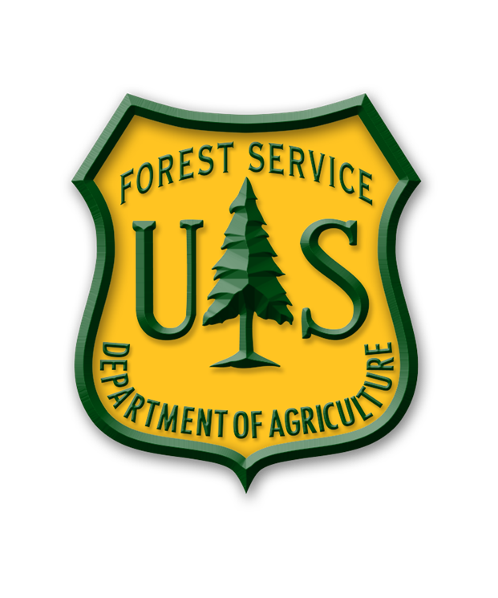
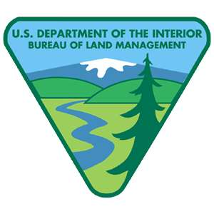
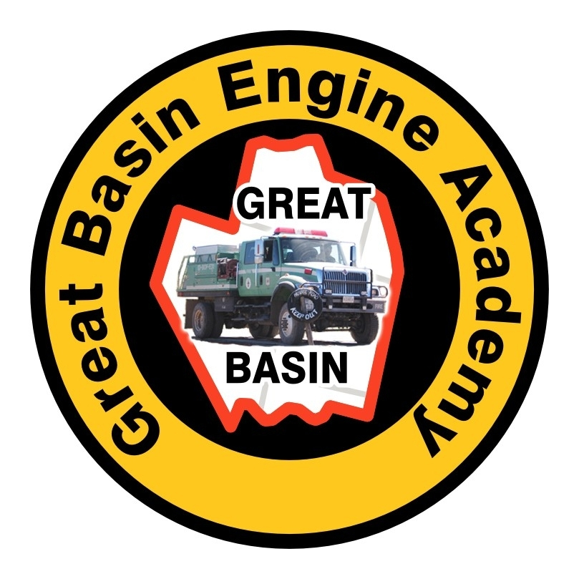

MEDIA ADVISORY INVITATION

2013 GREAT BASIN ENGINE ACADEMY

WHEN: Tuesday, April 23, 2013, 10am.
WHERE: Old St. George Airport Terminal, 317 S. Donlee Dr, St. George, Ut.
WHAT: U.S. Forest Service Great Basin Engine Academy. Local media are invited to attend “Engine Skills Day” as part of this event.

The Great Basin Engine Academy (GBEA) is an intense 80-hour course designed to expose the students to all aspects of wildland fire engine operations with an emphasis on practical application and testing.

Following is a brief description of activities planned for Tuesday, April 23, 2013. This day is critical in the student’s curriculum and is the longest and most complicated day of the academy. The Academy skills testing includes the following stations: advanced driving course, pumping/drafting and scenarios, evasive driving maneuvers course, I-zone backing exercise, and engine maintenance. On this day, you will see student’s skills tested driving wildland fire engines. For a preview video of what goes on at our academy visit: www.fs.usda.gov/goto/GBEA

“The objective of the Great Basin Engine Academy is to increase the safety of wildland firefighters” said, Kevin Greenhalgh, U.S. Forest Service, Great Basin Engine Academy Team Leader. “Improving and developing the firefighter’s skills in driving, pumping, and maintenance, will improve the professionalism of the students and increase their ability to operate safely and efficiently. This results in increased situational awareness for our wildland firefighters,” stated Greenhalgh.

Note: This event is not open to the public.

Attention assignment editors, reporters, & correspondents: Contact Kim Osborn at the U.S. Forest Service (801)710-3664 if you are interested in attending this event or for further information. Media representatives interested in attending this event need to meet at the Old St. George Airport Terminal at 10am on April 23, 2013.

###

