Fire Name __________________ Date ________________
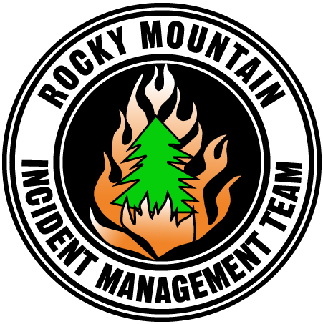
PIO _______________________ Phone _______________

Office
Email (Gmail, etc.)
User name and password
Contacts (Who is emailing? Where are
contacts stored?)
Phone Numbers
Internal
Media
Public
JIC or call center
Photos / Video
Web address (Flickr, Picassa, etc)
User name and password
Other sources (NG, etc.)?
Other photos/ videos (cd, etc.)?
Documentation
Format (electronic, cd, hard copy)
Where is it located?

Contacts
Agency contacts
Agency/ Contact Name
Email address/ Phone number
Agency/ Contact Name
Email address/ Phone number
Agency/ Contact Name
Email address/ Phone number
PIO contacts
Is there a JIC or call center? If yes,
who is manager?
Is there a document showing who is
responsible for what (Team/ JIC/
Agency PAO)?
Is there an org chart for PIOs?
Is there a spreadsheet listing PIOs,
contact info, quals, and 14th day?
Other contacts (anyone else we need
to maintain communication with)
Agency/ Contact Name
Email address/ Phone number
Agency/ Contact Name
Email address/ Phone number

Products
Updates
How many per day and when?
Update format (release, fact sheet,
etc.) and what logos?
Inciweb
Who is local super user?
Who is updating?
Are updates needed right away?
Twitter
What account has been used?
Who is updating?
Other social media sites?
Are there other sites we need to
maintain or know about (blogs,
Facebook, VOST, etc.)?
Other fire information sources?
Are there other websites getting posted
with fire information (agency or county
websites, etc.)? What are the web
addresses?

Media
Media Contact List
Is there a media list?
Any difficult media to be aware of?
Briefings
Date, time, and location
Daily or one-time event
Line visits
Date, time, and location
Daily or one-time event
Media Interest
How would you rate interest (heavy,
light, etc.)
Any story requests we need to follow
up on?
Do any issues keep coming up?

Community
Trapline
Is there a list of stops?
How long does it take?
Community Meetings
Number and attendance to date
Are any scheduled?
Meeting locations (either where they
have been held or possible locations)
Camp Tours
Are any scheduled?
Have any been tentatively requested?
Any unresolved business?

Special Concerns
Evacuations
List both current and past evacuations
and status
Closures
Road and Trail Closures
Area Closures
Fire Restrictions
Are there any in place? Is there an
official document or release?
Issues/ Challenges

