Important Telephone Numbers
Agency Phone

Orange County Public Information Hotline 714-628-7085
California Insurance Fraud Hot Line 800-927-HELP
Department of Consumer Affairs 800-952-5310
Red Cross 714-481-5300
Orange County Sheriff 714-647-7000
California Highway Patrol 800.tell.CHP
FEMA Help Line 800-621-FEMA
Cleveland National Forest 878-674-2901
Disaster Relief Assistance Centers
Irvine 949-341-8000
Tustin 714-801-7531

Arson Tip Line 800-540-8282

Orange County Fire Authority Website: ocfa.org

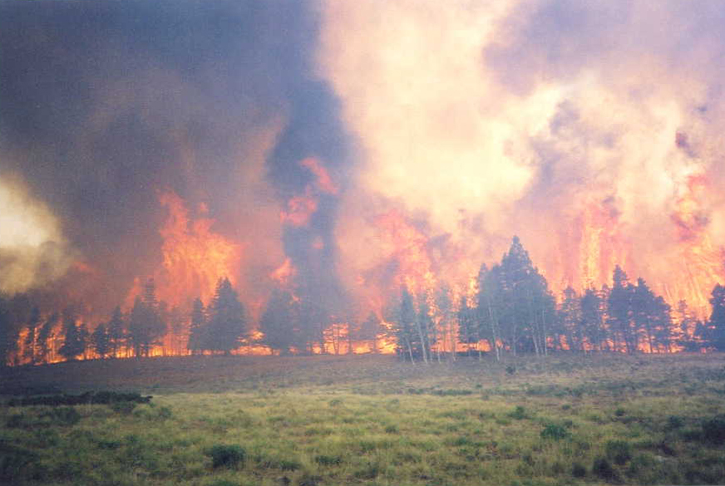
After The Fire
Returning Residents’

SAFETY

TIPS

Santiago Fire
Orange County
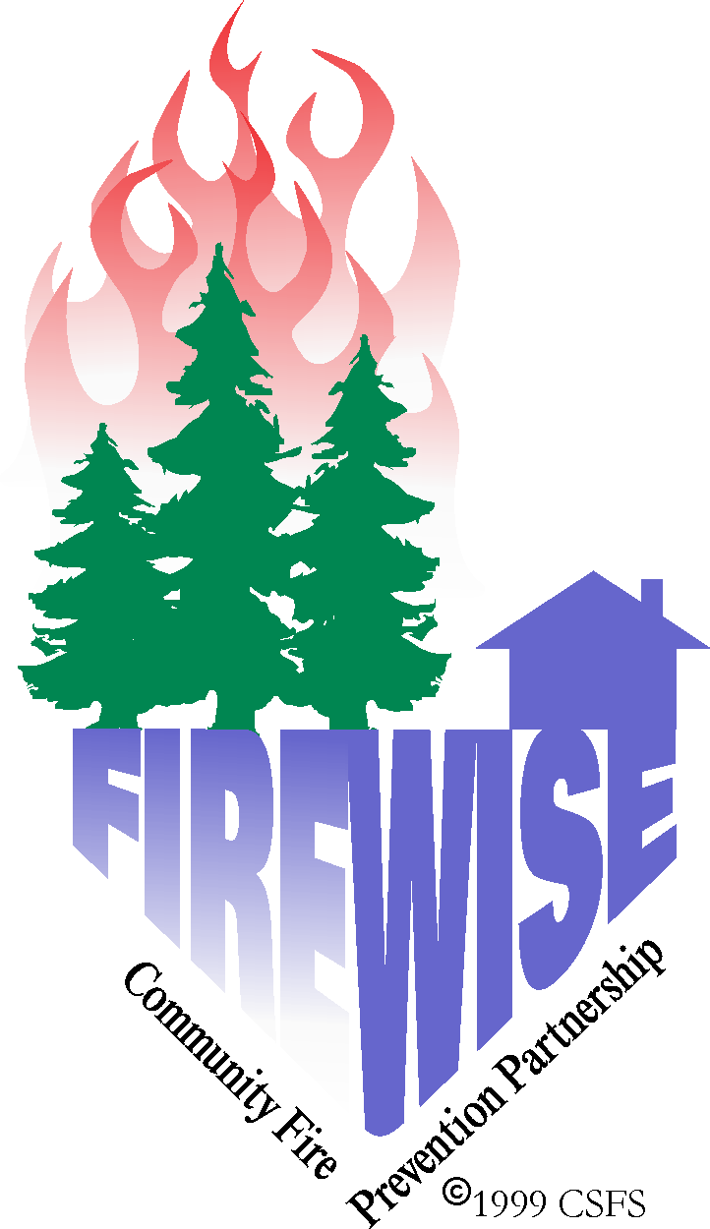

Table Of Contents

Electrical 1

Electric Safety Facts
Electric Safety Tips
Electric locations to avoid
Special Info. on Fuses and Circuit Breakers
Emergency Procedures on Electrical Fire
To Restore a fuse
To Reset a Circuit Breaker

Drinking Water 5

Restoring Water Systems

Solid Waste 6

Removing Debris

Heating Fuels 7

Checking Propane Tanks
Checking Home Heating Oil Tanks

Miscellaneous Safety Awareness 8

Ash Pits
Evaluation of Trees Damaged by Fire
Residual Smoke in Fire Interior
Fire Gel or Foam on Structures

species of the tree so check carefully to see if the fire or heat penetrated the bark. Where fire has burnt deep into the tree trunk, the tree should be considered unstable until checked.

- Check for burnt roots by probing the ground with a rod around the base of the tree and out away from the base several feet. The roots are generally six to eight inches below the surface. If you find that the roots have been burned you should consider this tree very unstable; it could easily be toppled by wind.

If the tree is scorched
A scorched tree is one that has lost part or all of its needles. Leaves will be dry and curled. Needles will be a light red or straw colored. Healthy deciduous trees are resilient and may possibly produce new branches and leaves, as well as sprouts at the base of the tree. Evergreen trees, particularly long-needled trees, may survive when partially scorched. An evergreen tree that has been damaged by fire is subject to bark beetle attack. Please seek professional assistance from the Colorado State Forest Service concerning measures for protecting evergreen trees from bark beetle attack.

Seek professional assistance before felling trees near power lines, houses or other improvements.

Residual Smoke In Fire Interior

Smoke may be present on the interior of the fire for several days following containment. This occurs as a result of stumps, roots, and other surface materials being exposed to changing temperatures and wind conditions. Smoke volume from these materials may fluctuate depending on weather conditions. This activity should not pose a risk and smoke will continue to dissipate until materials are fully consumed or extinguished by fire crews or weather.

Frequent calls to the fire department regarding this smoke may impact their resources.

Miscellaneous Safety Awareness
Ash Pits
Holes created by burned trees and stumps create ash pits, which are full of hot ashes. Mark them for your safety, as they can stay hot for many days following the fire, causing serious burns. Warn your family and neighbors, especially children. Tell them to watch for ash pits and to not put hands or feet in these holes—they are hot!

Evaluation of Trees Damaged by Fire
The following information will assist you in evaluating any trees that have been scorched or burnt by the fire. Identification of the type of tree affected is important and can easily be done. Two basic types of trees exist in this area: deciduous and evergreen. Deciduous trees are broad leaf trees that lose their leaves in the fall.

In this area we have quaking aspen (deciduous). Evergreen trees have needles and in this area we have ponderosa pine, Douglas-fir and Rocky Mountain juniper.

First: visually check the tree stability. Any tree weakened by fire may be a hazard. Winds are normally responsible for toppling weakened trees. The wind patterns in your area may have changed as a result of the loss of adjacent tree cover.

If the tree looks stable:
- Visually check for burnt, partially burnt or broken branches and tree tops that may fall.

- Check for burns on the tree trunk. If the bark on the trunk of the tree has been burned off or scorched by very high temperatures completely surround the tree’s circumference, the tree will not survive. This is because the living portion of the tree (cambium) was destroyed. The bark of the tree provides protection to the tree during fire. Bark thickness varies based upon the size and

8

Fire Recovery Safety Tips
REMEMBER – use caution and good judgment. Hazards may still exist, even though the fire is controlled.
Electrical Safety Facts
General
An important part of the disaster recovery is hazard recognition. Should you come across damaged or fallen power poles or lines, contact Southern California Edison at 800-684-8123 immediately. DO NOT TOUCH THE DOWNED WIRES. In the cleanup area, be especially careful when cutting trees and operating heavy equipment around power lines. Vegetation and power poles may have lost stability due to fire damage.
If a power line or pole should fall next to you while working in the area, do not walk – hop out of the area. (Using this technique, you will be less likely to be a conductor of electricity).
Electricity is always trying to go somewhere. It goes easily through conductors; it does not go easily through non-conductors.
Conductors Non-Conductors
Metal Rubber
Water Glass
Wet Things Plastic
Things In Water
(including animals/pets)

One of the most important fixtures in the conduction of electric current are utility poles. The fire or fire suppression actions may have dislodged or broken some of these poles, causing the wires to sag or break, resulting in extremely hazardous conditions. Do not touch anything at the scene.

1

Trees can also be dangerous conductors of electricity. When a tree falls or grows into contact with power wires, the electric power diverts and finds a path to the ground through the branches and the trunk. Anyone who comes into contact with these trees is subject to tragic consequences, since electric power can easily jump from the tree to the person.

Electrical Safety Tips

- Do not overload circuits; don’t operate several large appliances at the same time on the same circuit.

- Do not use extension cords to plug in many items on one outlet.

- Turn off appliances when you finish using them. Provide adequate air circulation around all appliances to prevent over-heating. Keep appliances clean, repaired and serviced.

- Check wires and plugs regularly. Replace worn or frayed wires. Do not run cords under carpets or across doorways.

- Be careful when replacing fuses or breakers. Keep the area near the circuit box dry and turn the main switch off before changing the fuse/breaker.
- Temporary lines should be removed from service.

Electrical Locations To Avoid

- Electrical meters and service lines coming into the home or other outbuildings.
- Any power supply line which appears to sag, show bare wire, or have insulation missing.
- Secured power sub-stations or any area identified as high voltage.
- Downed power lines.

2

HEATING FUELS
Checking Propane Tanks

Propane suppliers recommend homeowners contact them for an inspection prior to reusing their system. If the fire burned the tank, the pressure relief valve probably opened and released the contents of the tank. Tanks, brass and copper fittings, and lines may be heat-damaged and unsafe. Valves should be turned off and remain closed until the propane suppliers inspect the system.

Checking Home Heating Oil Tanks

Heating oil suppliers recommend homeowners contact them for an inspection prior to reusing their system. The tank may have shifted or fallen from the stand and fuel lines may have kinked or weakened. Heat from the fire may have caused the tank to warp or bulge. Non-vented tanks are more likely to bulge or show signs of stress. The fire may have loosened or damaged fittings and filters. If the tank is in tact and heating oil remains in the tank, the heating oil should still be good. If you have questions on the integrity of the tank, fuel lines, tank stand, or the fuel, or need assistance in moving the tank or returning it to service, contact your fuel supplier.

7

Solid Waste
Removing Debris

Cleanup of your property can expose you to potential health problems from hazardous materials. Wet down any debris to minimize health impacts from breathing dust particles. The use of a two-strap dust particulate mask with nose clip and coveralls will provide the best minimal protection. Leather gloves should be worn to protect your hands from sharp objects while removing debris.

Hazardous materials such as kitchen and bathroom cleaning products, paint, batteries, contaminated fuel and damaged fuel containers must be handled properly.

All hazardous materials should be labeled as to their contents if known! If you can’t identify the product, PLEASE let the personnel at the collection site know!

6

Special Information of Fuses & Circuit Breakers

Fuses and circuit breakers shut off the current whenever too much current tries to flow through a wire because of
- A short circuit, possibly caused by a bare wire touching the ground;
- Overloading, possibly caused by too many lights or appliances on one circuit; or
- By defective parts in an appliance.

Know where the main circuit or fuse box is located in your house. Be sure you can locate the main switch; it controls all of the power coming into the house and is usually inside the circuit box. In some cases, however, it may be located outside of the house. Fuse or circuit boxes generally are labeled to designate which area of the house the circuits or fuses serve.

Emergency Procedures for an Electrical Fire
- Call the fire department.
- Shut off power supply at the breaker, if possible.

Restoring Electric Power

If, upon returning to your residence, there is no electrical power, please check to make sure the main breaker is on. If the breakers are on and power is still not present, please call to report the power outage to Southern California Edison at 800-684-8123. Reporting problems like a down or broken wire will speed up the process of power restoration.
- Stand off to one side of the breaker box when turning on the main breaker. Do not stand directly in front of the box.
- If any smells of hot electrical insulation or sparking occurs, turn of the breaker immediately and call an electrician.
- If electrical lights or appliances appear brighter than normal, turn off main breaker. The service entrance needs to be checked.

3

To Change A Fuse

Try to find the cause of the blown fuse, and correct it by disconnecting the defective appliance or appliances causing the overload or short circuit. Shut off the main power switch when you change the fuse.

Do not replace fuses with a higher amp rating fuse than you removed.

Turn on the main switch to restore the power.

If the fuse blows again, leave it alone and contact a certified electrician. Other problems may exist and should be investigated to remove the possibility of an electrical fire.

To Reset A Circuit Breaker

Try to find the cause of the overload or short circuit and correct it by disconnecting the defective appliance or appliances. Turn the switch to “on” to reset and restore power. If breaker trips again, leave it alone and contact a certified electrician. Other problems may exist and should be found to remove the possibility of an electrical fire.

4

Drinking Water
Restoring Water Systems

Unless impacted by a fuel spill, the fire should not have affected wells at undamaged homes. If your house was damaged, your water system may potentially have become contaminated with bacteria due to loss of water pressure. In this case it is recommended that the well be disinfected and the water be tested before consumption. To disinfect your water system, pour ½ - 1 cup of chlorine bleach inside the well casing and turn on all faucets until a chlorine scent in noticed. Allow the chlorine solution to remain in the system overnight. The following morning, open all faucets and flush the system until free of chlorine smell.

Is There Fire Retardant Gel On Your House?

Fire retardant gel or compressed air foam may have been applied to your home or other structures to protect them during fire suppression operations. These chemicals are not hazardous to you or your pets and should not damage your paint or other exterior surfaces. The gel may be removed by simply washing your home with a garden hose or pressure washer. Please contact your local fire station if you have any questions or concerns.

5

