Excel 2013 & 2016: Accessible Excel Forms, Part 2
Contents
Excel 2013 & 2016: Accessible Excel Forms, Part 2 1
Introduction 1
Controlling the Kind of Data Being Entered 1
Restricting the Format of Data Using the Format Cell Dialog Box 1
Restricting the Range of Data Using the Data Validation Dialog Box 3
Locking and Protecting Your Form 4
Locking All Cells and Unlocking Selected Cells 4
Protecting the Worksheet 5
Protecting the Workbook 6
To Summarize 6

Introduction
Forms in Excel help the end user fill out information, and also help the form owner to quickly access that information. While some users will print out forms, our emphasis is on forms that are used electronically. To make an Excel form accessible, we focus on:
- Allowing the end user to navigate using the keyboard.
- Providing helpful instructions that are accessible to visually impaired users who employ assistive technology screen readers.
This is the second of two modules about Excel Forms.

Controlling the Kind of Data Being Entered
You can restrict cells to only allow certain kinds of data, or only allow data in a certain format. The Format Cell and Data Validation dialog boxes contain tools for restricting how data is entered.

Restricting the Format of Data Using the Format Cell Dialog Box
You can tell Excel that certain cells are date fields, numeric fields, or text fields. In this example we’ll specify a date field in a certain format.
- Select the cell where you want your date field.
- Right-click on the cell, and choose Format Cells. The Format Cells dialog box will open.
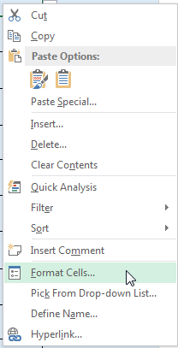
- In the Number tab of the dialog, choose Date. Many options will appear on the right side.
- Choose the date format you want. Possibly the best two to choose are the two with the asterisks because they can adjust to reflect the settings in the user’s operating system. In this example we’ll choose the numeric “month/day/year” format.
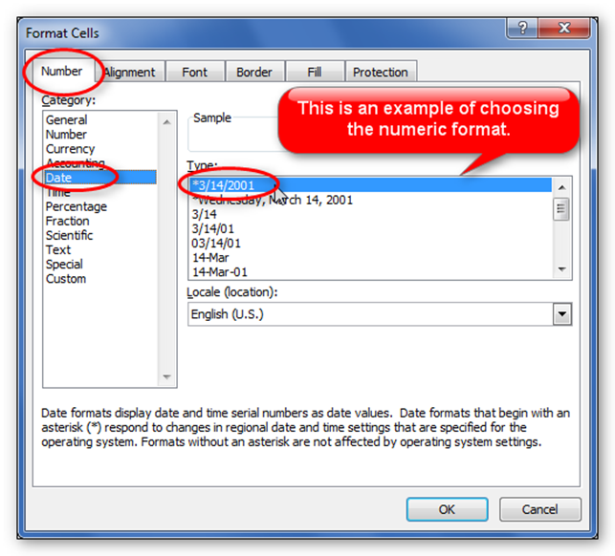
- Now click OK to accept changes and close the dialog box.
Test your field. You will notice that if you type a two digit year, Excel will change the format to a four digit year. On the other hand, if you type the date in words, it will not change it.

Restricting the Range of Data Using the Data Validation Dialog Box
Continuing to use the example of a date field, in this case we will limit a cell to only accept dates within a certain range.
- Select the cell in the form where you want the user to enter a date.
- In the Data tab, choose Data Validation again. The Data Validation dialog box opens.
- In the Settings tab, in the Allow dropdown box, choose Date.
- Uncheck the Ignore Blank checkbox if leaving the field blank is not acceptable.
- In the Data dropdown box, choose what you want. In this example we’ll choose between.
- In the Start date field, type in the date representing the first acceptable date.
- In the End date field, type in the date you want as the last acceptable date.
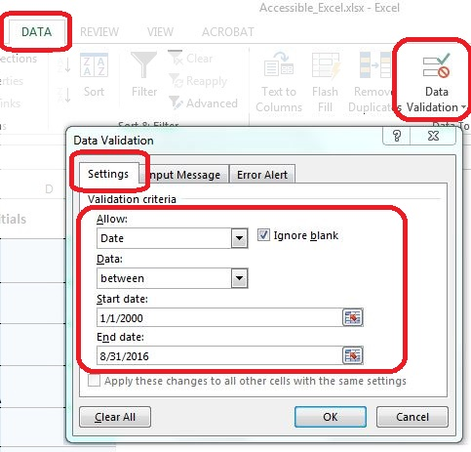
- Finally, click OK to close the Data Validation dialog box.
Now test the date field. Dates outside the range you specified should give the user an error message. Try different values and formats. Now, for example, if you type, “March,” in word form, Excel will convert it to the form you specified.
Double-check that your data validation text, covered previously, contains a clear, helpful description of what you expect the user to enter, and in what format, to avoid frustration.

Locking and Protecting Your Form
To keep your form safe, you want to prevent the end users from accidentally changing anything on your spreadsheet, other than the input cells you want them to fill out. We will go through the steps to accomplish this.

Locking All Cells and Unlocking Selected Cells
- Start by selecting the entire worksheet. Click the Select All button on the top left corner of the worksheet, or press Ctrl+A.
- Right-click anywhere on the worksheet, and choose Format Cells.
- In the Format Cells dialog box, click on the Protection tab, and click the Locked checkbox so it is checked.
- Click OK to close the dialog box. You have now locked all the cells.
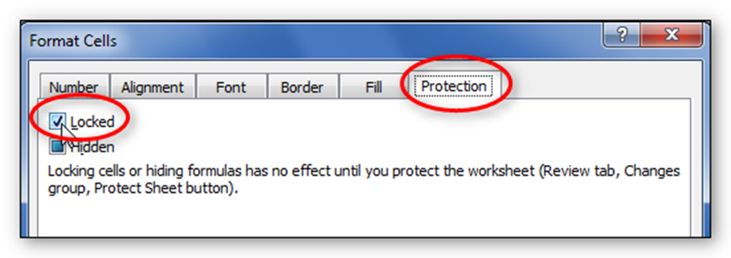
Next, you must select just the cells where you want the user to input data, and unlock them. Follow these steps:
- Hold down the Control key while left-clicking, one after the other, all the cells you want to select.
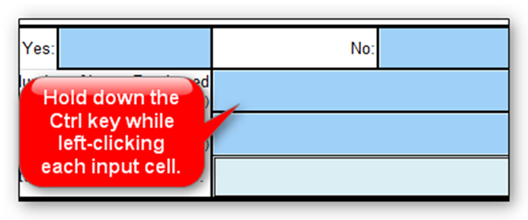
- With multiple cells selected, and your cursor hovering over one of the selected cells, right-click and choose Format Cells.
- Click on the Protection tab in the Format Cells dialog box, and click the Locked checkbox and the Hidden checkbox so they are both unchecked.
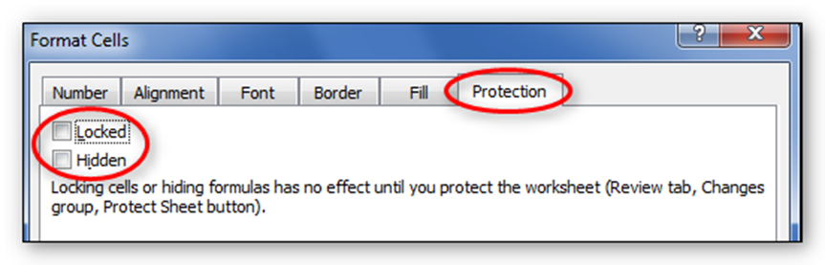
- Click OK to close the dialog box. You have now unlocked all the cells you selected.
Note that locking and unlocking cells has no effect until you protect your worksheet. We’ll cover that next.

Protecting the Worksheet
Protecting the Worksheet “activates” the locking and unlocking of cells you performed in the previous section.
- Click on the Review tab of the Ribbon.
- In the Changes group, click the Protect Sheet tool. A Protect Sheet dialog box appears.
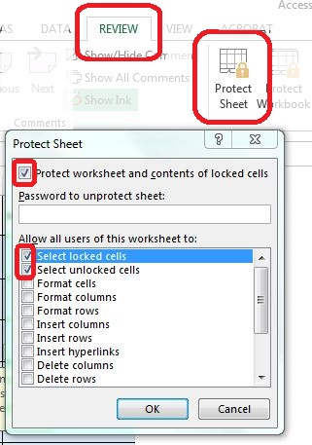
- If you want to prevent others from unprotecting the worksheet, type in a password. Otherwise, just leave the password field blank. If you type a password, you are prompted to type it again.
- Be sure to leave the first two checkboxes checked: Select locked cells, and Select unlocked cells. This will allow the screen reader to read the locked instruction cells, as well as fill out the unlocked form fields.
- When finished, click OK to close the Protect Sheet dialog box.
You have now protected your worksheet, so that only unlocked cells can be edited. Check your work, to make sure you have not accidentally left an input cell locked.

Protecting the Workbook
If your form has more than one worksheet, you will want to protect the entire workbook as well. This prevents the end user from deleting or copying worksheets, or renaming tabs.
- Click the Review tab and choose the Protect Workbook tool from the Changes group. The Protect Structure and Windows dialog box will open.
- Click both checkboxes, for Structure and for Windows, and put in a password if you want one. Click OK.
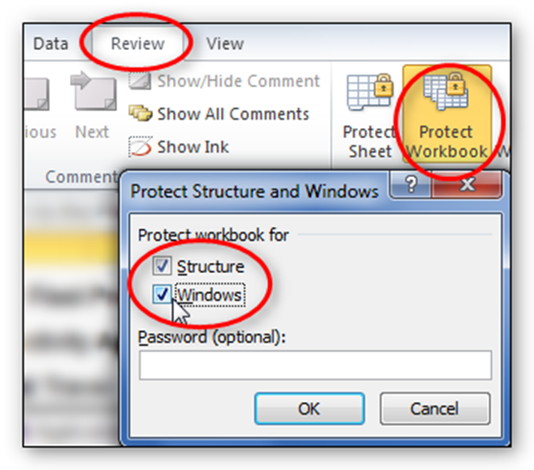
- You will be prompted to repeat the password. Type it in again and click OK.

To Summarize
We discussed:
- Controlling the kind of data being entered, using both the Format Cell and Data Validation dialog boxes.
- Locking and protecting your form and its contents.
If you follow the steps in the previous module and this module, you’ll have an Excel Form that will be easy to understand and will also be accessible to just about anyone, including those using assistive technologies. Remember to review and follow the accessibility requirements explained in the other Excel modules as well.

