Overview of Changes in the EPM Data Warehouse

June 30, 2022

The EPM Data Warehouse, formerly known as OBIEE (Oracle Business Intelligence Enterprise Edition), is being updated on July 11, 2022.

It will have a new look and feel. It will operate in the same way with some new features and minor changes. You will be able to run your existing reports and dashboards. When you sign into the EPM Data Warehouse, on July 11, you’ll notice changes after the upgrade.

This overview contains information about changes to the EPM Data Warehouse due to the upgrade.

**Changes include the following:**

* A new look and feel with the State of Minnesota branding
* Renamed Statewide dashboards to match the State branding
* New search and sort features inside the Subject Areas
* New search feature to look up a Subject Area when creating a new analysis
* Save a column to My Folders in the Catalog and reuse it
* Current Favorites will not migrate to the upgraded version
* Warehouse Training (OBIEE) Tile Unavailability

**Questions?** Contact the SWIFT Help Desk: [SWIFT.project@state.mn.us](mailto:SWIFT.project@state.mn.us).

## A new look and feel with the State of Minnesota branding

The official title is “EPM Data Warehouse.” You might know it previously as “OBIEE,” “SWIFT Data Warehouse,” “State of Minnesota Business Intelligence,” or “Data Warehouse.”

It will have the same brand as other State enterprise systems such as the Administrative Portal or the Self Service Portal.

Updated header of the EPM Data Warehouse to match other State of Minnesota enterprise systems.

## Renamed Statewide dashboards to match the State branding

* “OBIEE Support” will become the “EPM Data Warehouse Quick Links.”
* “OBIEE Data Dictionary” will become the “EPM Data Warehouse Data Dictionary.”
* “OBIEE Overview” will become the “EPM Data Warehouse Overview.”

New search and sort features inside the Subject Areas  
You will be able to search and sort inside the Subject Areas to easily find a folder or data element within an existing report. These features work in both the Criteria and Results tabs

When you are inside the Subject Areas pane of an existing report, select the **Search** icon. It looks like a looking glass. Enter a keyword or the wildcard such as “%” in the **Search** box and select the **Enter** key. The folder or data element will appear at the top of the list.

Also, you can sort the order of the folders by selecting the **Sort** icon. It is two arrows, one pointing up and one pointing down.

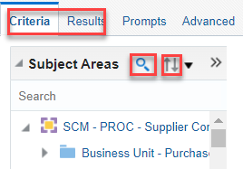

New search feature to look up Subject Areas when creating a new analysis   
When you select **New** on the top menu to create a new analysis or prompt, you’ll see a popup window. You can enter a search term to find Subject Areas more easily from the list.

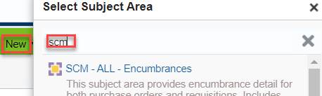

## Save a column to My Folders in the Catalog and reuse it

The upgrade will allow you to save columns in My Folder. It is useful when creating a new analysis from the same Subject Area as an existing report. You can save a data set into a column from an existing report and then add it to a new analysis in the same Subject Area.

**Step 1: Save a data set from an existing report into a column**

1. When you are in an existing report, open the Criteria tab. On the Selected Columns section, open the **Menu** icon. It looks like a gear. Select the “Save Column As” option.

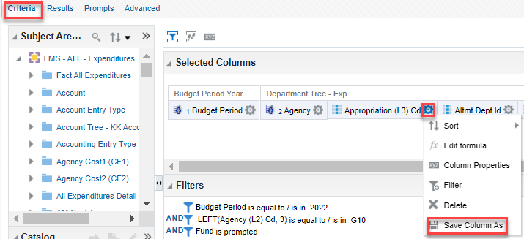

1. The EPM Data Warehouse displays the Save As page. On the Folders section, select MyFolders. If you don’t have a Subject Area folder for it, the EPM Data Warehouse will create one for you. Update the Name and Description fields as desired. Select OK.

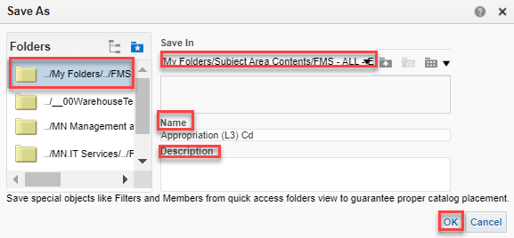

**Step 2: Add the saved column in the new analysis.**

1. **Create a new analysis. On the global header, select New. Then, select “Analysis.” The** Select Subject Area **window appears. Select the same Subject Area as the original report.**
2. **The EPM Data Warehouse opens an untitled analysis page. In the right column go to the** Catalog **section and open My Folders. Open the Subject Area Content folder. Your saved column is in there.**
3. **Double select or drag and drop it into the** Select Columns **section and complete the analysis.**

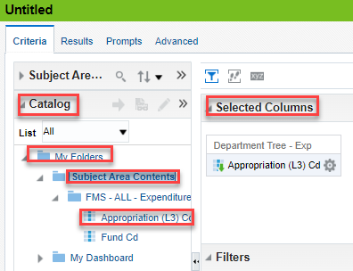

## Current Favorites will not migrate to the upgraded version

**IMPORTANT!** Anything stored in Favorites will not be migrated to the upgraded version.

Make a list of your Favorites now including the name and location of the report in a file. Once the upgrade is live, navigate to the location of these items and add them back into Favorites. Make sure to review the name changes for any of the renamed Statewide dashboards.