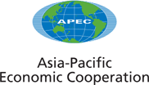
___________________________________________________________________________
2004/AMM/033rev2
Agenda Item: XII

APEC Course of Action on Fighting Corruption and Ensuring Transparency

Purpose: Consideration

Submitted by: Chile, Korea, and United States

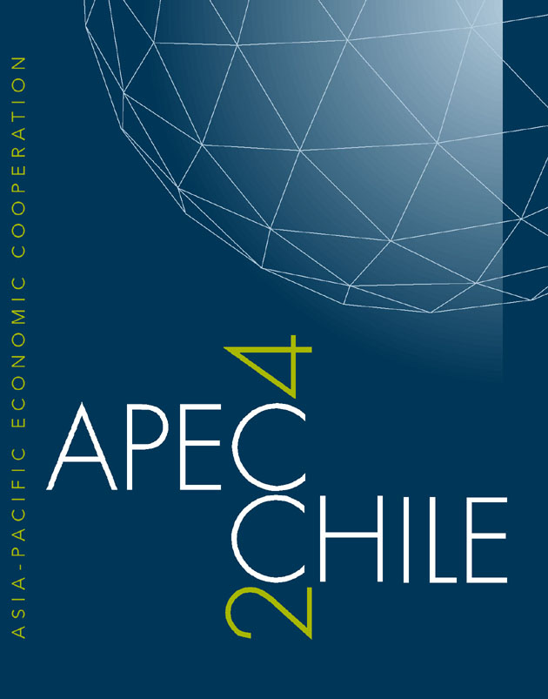 | 16th APEC Ministerial Meeting  Santiago, Chile  17-18 November 2004

APEC COURSE OF ACTION ON FIGHTING CORRUPTION AND ENSURING TRANSPARENCY

On September 25-26, APEC government officials and senior experts met in Santiago to outline key recommendations to pursue the fight against corruption with a view to implement, synergize, and coordinate our efforts in adopting actions contained in the United Nations Convention Against Corruption (UNCAC) and other multilateral frameworks to fight corruption and ensure transparency, including the APEC Transparency Standards.

We reaffirm our commitment to cooperate in APEC to implement concrete actions to fight corruption and ensure transparency and accountability in the proper management of public affairs and public property, and we hereby agree to the following actions, where appropriate and within the means of each economy and in accordance with the fundamental principles of each economy’s legal system:

I. Take All Appropriate Steps Towards Ratification of, or Accession to, and Implementation of the UNCAC*:

- Intensify our efforts to combat corruption and other unethical practices, strengthen a culture of transparency, ensure more efficient public management, and complete all appropriate steps to ratify or accede to, and implement the UNCAC.

- Develop training and capacity building efforts to help on the effective implementation of the UNCAC’s provisions for fighting corruption.

- Work to strengthen international cooperation in preventing and combating corruption as called for in the UNCAC including extradition, mutual legal assistance, the recovery and return of proceeds of corruption.

II. Strengthen Measures to Effectively Prevent and Fight Corruption and Ensure Transparency by Recommending and Assisting Member Economies to:

- Establish objective and transparent criteria that assure openness for merit, equity, efficiency for the recruitment of civil servants, and promote the highest levels of competence and integrity.

- Adopt all necessary measures to enhance the transparency of public administration, particularly with regard to organization, functioning and decision-making processes.

- Develop and implement appropriate public financial disclosure mechanisms or codes of conduct for senior-level public officials.

- Institute effective government measures aimed at preventing corruption and ensuring transparency, including the implementation of the APEC Leaders Transparency Standards in all areas endorsed by Leaders:

  - Government Procurement
  - Services
  - Investment
  - Competition Policy and Regulatory Reform
  - Standards and Conformance
  - Intellectual Property
  - Market Access
  - Customs Procedures
  - Business Mobility

- Afford one another the widest measure of mutual legal assistance, in investigations, prosecutions and judicial proceedings related to corruption and other offences covered by the UNCAC.

- Designate appropriate authorities in each economy, with comparable powers on fighting corruption, to include cooperation among judicial and law enforcement agencies and seek to establish a functioning regional network of such authorities.

III. Deny Safe Haven to Officials and Individuals Guilty of Public Corruption

- Promote cooperation among financial intelligence units of APEC members including, where appropriate, through existing institutional mechanisms.

- Encourage each economy to promulgate rules to deny entry and safe haven, when appropriate, to Officials and individuals guilty of public corruption, those who corrupt them, and their assets.

- Implement, as appropriate, the revised Financial Action Task Force (FATF) 40 Recommendations and FATF’s Special Recommendations on Terrorist Financing.

- Work cooperatively, within the means of each economy, using mechanisms in the UNCAC, FATF, or other international initiatives and in accordance with domestic law, to investigate and prosecute corruption offenses and to trace, freeze, and recover the proceeds of corruption.

IV. Fight both Public and Private Sector Corruption

- Develop effective actions to fight all forms of bribery, taking into account the OECD Convention on Combating Bribery of Foreign Public Officials in International Business Transactions or other relevant anticorruption conventions or initiatives.

- Adopt and encourage measures to prevent corruption by improving accounting, inspecting, and auditing standards in both the public and private sectors in accordance with provisions of the UNCAC.

- Support the recommendations of the APEC Business Advisory Council (ABAC) to operate their business affairs with the highest level of integrity and to implement effective anticorruption measures in their businesses, wherever they operate.

V. Public-Private Partnerships

- Involve, in accordance with each economy’s domestic law, individuals and groups outside the public sector, such as civil society, nongovernmental organizations, community-based organizations, and the private sector in efforts to fight corruption, ensure transparency, promote good governance, strengthen public financial management accountability systems, and advance the rule of law.

VI. Cooperation Among APEC Member Economies to Combat Corruption and Ensure Transparency in the Region

- Work together and intensify actions to fight corruption and ensure transparency in APEC, especially by means of cooperation and the exchange of information, to promote implementation strategies for existing anticorruption and transparency commitments adopted by our governments, and to coordinate work across all relevant groups within APEC (e.g., SOM, CTI, GPEG, SCCP, and IEGBM).

- Coordinate, where appropriate, with other anticorruption and transparency initiatives including the UNCAC, OECD Convention on Combating Bribery of Foreign Public Officials in International Business Transactions, FATF, the ADB/OECD Anticorruption Action Plan for the Asia Pacific region, and Inter-American Convention Against Corruption.

- Recommend closer APEC cooperation, where appropriate, with the OECD including a joint APEC-OECD seminar on anticorruption, and similarly to explore joint partnerships, seminars, and workshops with the UN, ADB, OAS, the World Bank, the Global Forum on Fighting Corruption and Safeguarding Integrity, and other appropriate multilateral intergovernmental organizations.

- Initiate and develop innovative, coordinated and targeted training and capacity building tools (e.g., an APEC Anticorruption and Transparency Training (ACT) Program), a region-wide public outreach program, or other initiatives that provide regional technical expertise and raise awareness).

- Encourage all relevant economies to sign bilateral and multilateral agreements that will provide for assistance and cooperation in areas covered by the UNCAC.

VII. From Santiago to Seoul

- In 2005, establish an Experts’ Task Force to serve in an advisory role to APEC Senior Officials. The terms of reference for the task force shall be developed for approval by SOM I in 2005, outlining a more concrete roadmap for accelerating the implementation and tracking the progress made of our commitments to fight corruption and ensure transparency:

  - Strengthen and further refine the APEC course of action adopted in the Santiago Commitment to Fight Corruption and Ensure Transparency towards effective implementation and monitoring by all APEC economies.

  - Encourage APEC Member Economies, where appropriate, to put into practice measures and mechanisms outlined in the UNCAC.

  - Help implement the APEC Transparency Standards by 2005 into domestic legal regimes.

  - Recommend any additional actions to fight corruption and ensure transparency, including further areas related to corruption involving the private sector and denying them of their safe haven.

  - Develop specific benchmarks to help ensure that each APEC Member Economy is taking all appropriate steps and measures to implement agreed upon commitments.

  - Organize an APEC Anticorruption and Transparency Symposium in Korea in 2005 to showcase the progress that APEC economies have done to fight corruption and ensure transparency and discuss further cooperation on any additional actions that need to be built into the APEC work program.

* APEC member economies that are not members of the United Nations will positively consider and make efforts to achieve the measures, practices, and goals set out by the UNCAC through ways consistent with their respective status.

