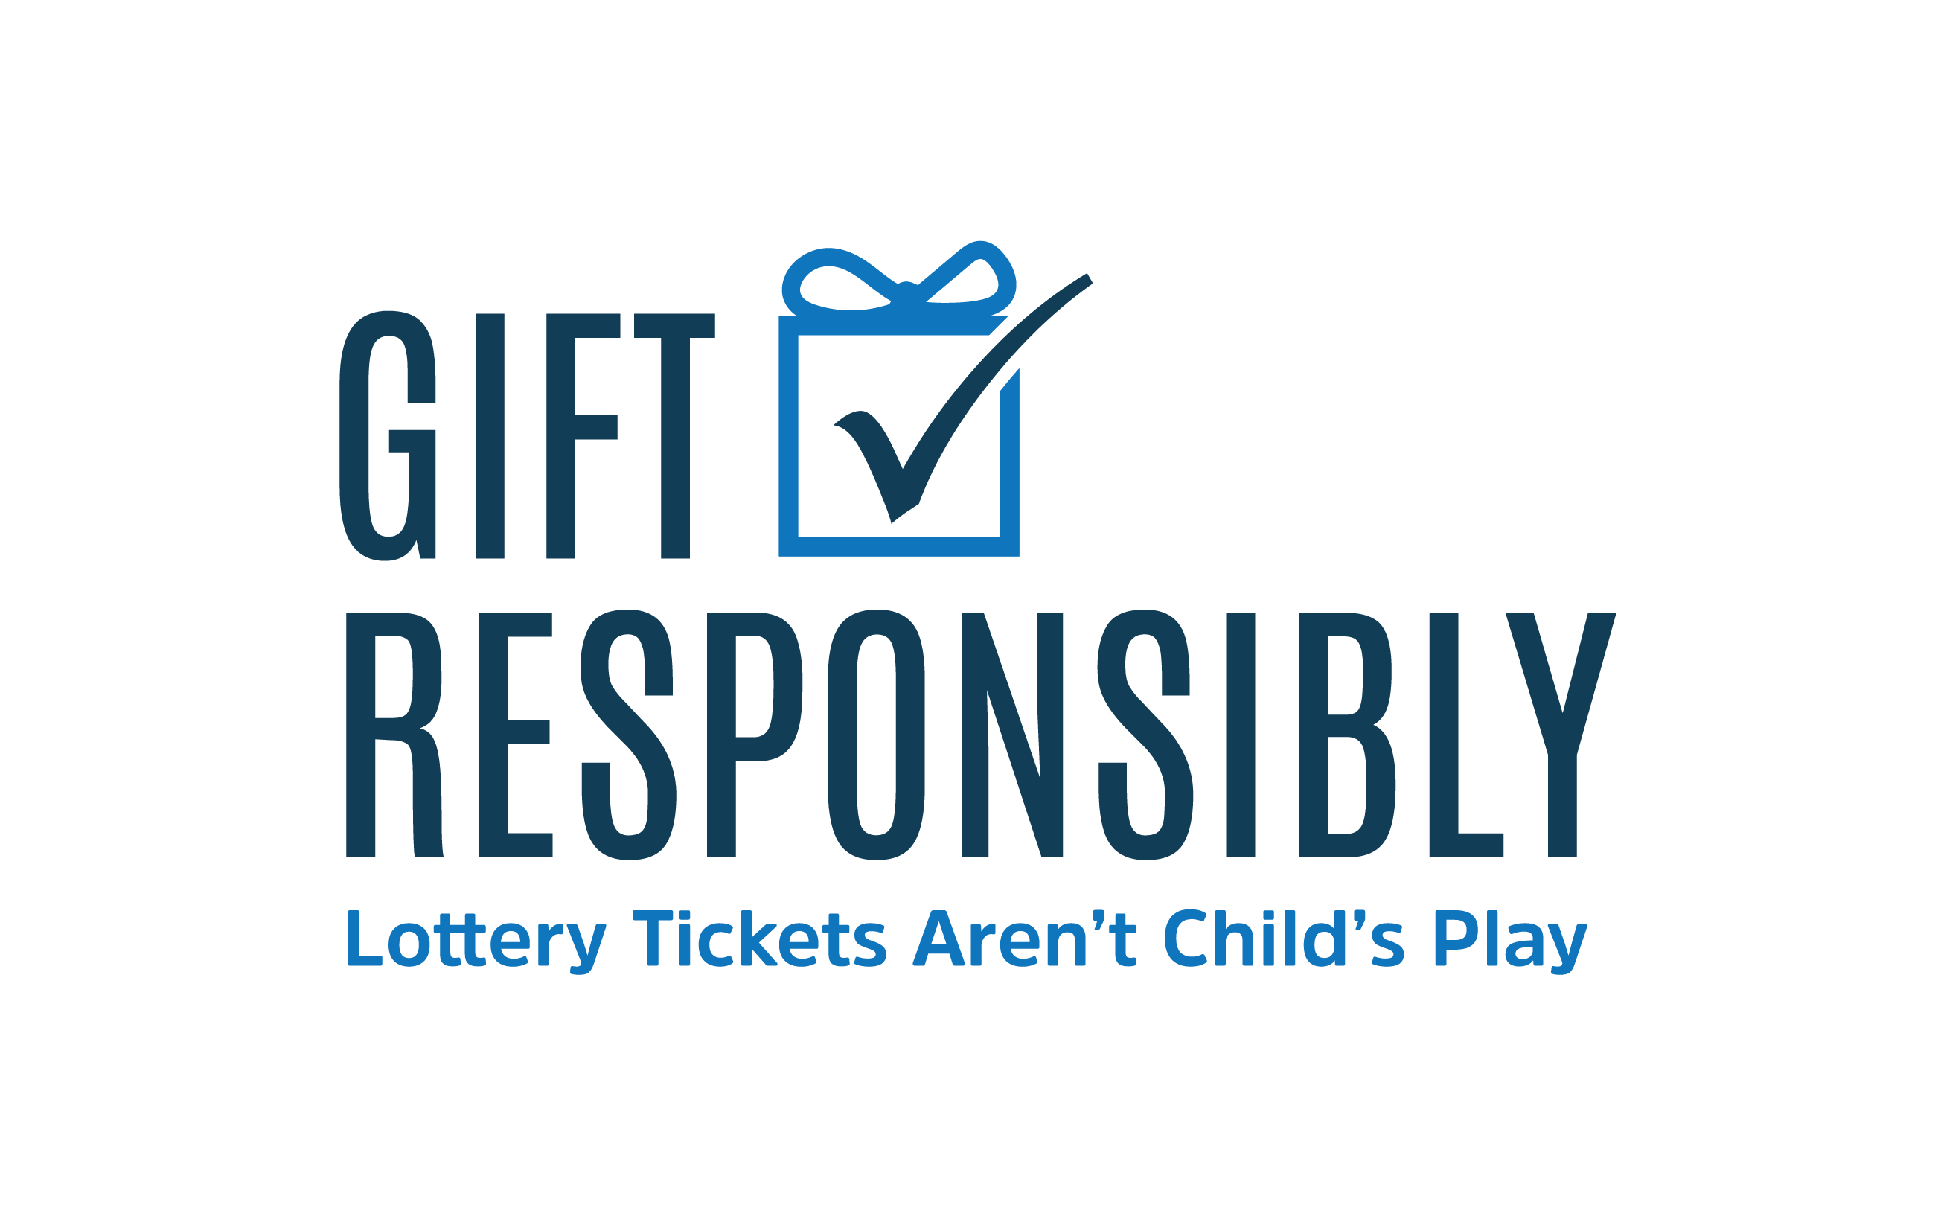 | (Your Logo Here)
(Organization name) Joins 2023 Gift Responsibly Campaign to Raise Awareness of Youth Gambling Risks

FOR IMMEDIATE RELEASE
(Date of Press Release)

CONTACT:
(Contact Name)
(Contact Email)
(Contact Phone Number)

(City, State) – The (Organization Name) today announced its commitment as a (Participation Level or remove if Non-Lottery participant) participant of the 2023 Gift Responsibly Campaign, joining lotteries and community organizations across North America and around the world to raise awareness about the risks of underage lottery use. The campaign is organized by the National Council on Problem Gambling (NCPG) and the International Center for Youth Gambling Problems and High-Risk Behaviors at McGill University.

Research shows that the earlier a person’s participation or exposure to gambling is in childhood, the more likely they are to develop a gambling problem later in life. Gambling exposure during childhood is often through some kind of lottery product, such as lottery tickets or scratch offs. Often these items are given to a child by an adult who is unaware of the associated risks.

(Quote from organizational representative about why your organization joined the campaign)

(Organization Name) has signed on to the 2023 Gift Responsibly Campaign as a (Participation Level or remove if Non-Lottery participant) participant. During November and December, (Organization Name) will work to promote awareness about the risks of underage lottery use by (list campaign activities i.e. public service announcements, social media, in-store signage, and retailer trainings.)

“The potential long-term risks associated with underage gambling exposure cannot be understated,” said Keith Whyte, NCPG Executive Director. “I commend each Gift Responsibly Campaign participant for their commitment to raising awareness about the risks of youth gambling. Now, more than ever, we must continue to insist that lottery tickets are never appropriate gifts for children.”

(Organization to add more about its involvement with NCPG Affiliate and/or other community organizations or statement about organizations overall commitment to social responsibility & responsible gambling.)

About (Organizational name)
(Your boilerplate)

About the National Council on Problem Gambling
The National Council on Problem Gambling (NCPG) is neutral on legalized gambling. Based in Washington DC, NCPG is the only national nonprofit organization that seeks to minimize the economic and social costs associated with gambling addiction. If you or someone you know may have a gambling problem, contact the National Problem Gambling Helpline, which offers hope and help without stigma or shame. Call or text 1-800-GAMBLER or visit www.1800gamblerchat.org. Help is available 24/7 – it is free and confidential.

About International Center for Youth Gambling Problems and High-Risk Behaviors at McGill University
For over 20 years, the International Centre for Youth Gambling Problems and High-Risk Behaviours at McGill University has been at the forefront of leading-edge research aimed at identifying and understanding the critical factors related to youth gambling issues.

###

